REPUBLIC OF CAMEROON
Peace - Work - Fatherland

AFRICAN INSTITUTE OF COMPUTER SCIENCES
P.O. Box: 13719 Yaoundé-Cameroon
Tel: (+237) 242 72 99 57 Fax: 22729958
Site : www.iaicameroun.com
Email : contact@iaicameroun.com
REPUBLIQUE DU CAMEROON
Paix - Travail – Patrie

MI-TECH sarlu
Innovation, Passion, Excellence
P.O. Box 6998 Yaoundé, Cameroon
Tel : 696 767 009 / 681 191 547
Site : https://mi-tech.site
Email : contact@mi-tech.site

INTERNSHIP REPORT
CONCEPTION AND REALIZATION OF A SMART COMMUNITY PLATFORM FOR REAL-TIME INCIDENT REPORTING (SOS REPORT)

Internship carried from the 6th of July to 30th September 2026
In view of obtaining a Higher Technician Diploma (HTD) in Computer Sciences.
Option: Software Engineering –
Written By:
AKAMBA Walvede Daniel
Level II student at African Institute of Computer Science Cameroon

Supervised By:
Professional Supervisor
Mr. CHEBEU Sergio Junior
Full Stack Developer at MI-TECH
Academic Supervisor
Mr. BILL Nelson
Lecturer at AICS

Academic Year 2025 - 2026

DEDICATION

This work is dedicated to my grandmother Mme. KOUNOU Anastasie and to the entire AKAMBA family members for their numerous encouragement and support towards my academic success.

ACKNOWLEDGEMENTSThis work is dedicated to my grandmother Mme. KOUNOU Anastasie and to the entire AKAMBA family members for their numerous encouragement and support towards my academic success.

ACKNOWLEDGEMENTS

My gratitude goes to the following people who assisted in the realization of this project:

- The Resident Representative of AICS-Cameroon, Mr. Armand Claude ABANDA, for his words of encouragement and the different advices brought to us.
- To the honorable members of the jury who grant us their precious time to evaluate and judge our work.
- Our professional supervisor, Mr. Sergio Junior CHEBEU for the numerous advices, guidance and professional expertise shared with us.
- Our academic supervisor Mr. BILL Nelson for his support and help in the realization of the internship report.
- To our teachers for their numerous advices and guidance throughout the academic year.
- To the MI – Tech team for their numerous advices and guidance throughout the internship period.
- To my beloved parents Mr. & Mme. AKAMBA for their endless love, and moral support.
- To my beloved grandmother Mme. KOUNOU Anastasie for her endless love, moral and financial support.
- To my uncle and father Mr. Arthur ESSINDI for his trust, encouragement, advices and financial support.
- To my brother and my sisters for their love support and care regarding my studies.
- To our beloved friends, Mrs. AFANWI Kelly, KEIGOUM Ariane, DJOKO Joyce and all my classmates for their support and collaborative work throughout the academic year and for their numerous encouragements, love, and moral support.
- To each and every one not listed who participated in the realization of this project.

SUMMARY

DEDICATION I
ACKNOWLEDGEMENTS II
SUMMARY III
LIST OF TABLES V
LIST OF FIGURES VII
GLOSSARY X
ABSTRACT XII
RESUME XIII
GENERAL INTRODUCTION 1
PHASE ONE: INSERTION PHASE 2
PHASE TWO: TECHNICAL PHASE 16
FILE 1: THE EXISTING SYSTEM 18
FILE 2: THE SPECIFICATION BOOK 28
FILE 3: THE ANALYSIS PHASE 44
FILE 4: CONCEPTION PHASE 79
FILE 5: REALIZATION PHASE 94
FILE 6: TEST OF FUNCTIONAITIES 108
FILE 7: INSTALLATION GUIDE AND USER GUIDE 117
PERSPECTIVES 130
GENERAL CONCLUSION 131
ANNEXES XIII
BIBLIOGRAPHY XIV
WEBOGRAPHY XV
TABLE OF CONTENT XVI

LIST OF TABLES

Table 1: Team Project Table 8
Table 2: Team Members and Roles 9
Table 3: Hardware Resource 12
Table 4: Software Resources 13
Table 5: Criticism Table 24
Table 6: Functional Needs 33
Table 7: Chronogram of activities 36
Table 8: Software Resources (source: https://www.microsoft.com/en-us/d/windows-11-pro/dg7gmgf0d8h4) 38
Table 9: Hardware Resources 39
Table 10: Human Resources 40
Table 11: Estimation cost of project 41
Table 12: List of participants 41
Table 13: Comparison between MERISE and UML 49
Table 14: Understanding 2TUP branches 51
Table 15: Components of use case diagram 53
Table 16: Actors of our System 54
Table 17: Textual Description of Authentification 57
Table 18: Textual Description of Report Incident 59
Table 19: Textual Description of Consult Alert Evidences 60
Table 20: Textual Description of Monitor Incident 62
Table 21: Textual Description of Receive Area Alerts 63
Table 22: Components of the Communication diagram 65
Table 23: Components of the Sequence diagram 69
Table 24: Components of the Activity diagram 74
Table 25: Components of the Class diagram 85
Table 26: Components of the State Machine diagram 88
Table 27: Components of the Package diagram 91
Table 28: Components of the Deployment diagram 98
Table 29: Components of the Component diagram 101
Table 30: Tools used to develop SOS Report 103
Table 31: Installation Steps for Live Presentation 120

LIST OF FIGURES

Figure 1: Mercy Innovative Tech Organizational Chart 10
Figure 2: Mercy Innovative Tech Geographical Location (Source : EdrawMax) 11
Figure 3: Gantt Project Planning 37
Figure 4:UML diagrams (source: https://images.edrawsoft.com/articles/what-is-uml/uml-diagram-types.png) 48
Figure 5: 2TUP diagram (Source: Miss. NYANGONO NDO EMMANUELLA DORETTE EMIE’S Report (session 2024)) 50
Figure 6: formalism of a use case diagram 52
Figure 7: General Use Case Diagram of SOS Report 55
Figure 8: Specific Use Case of Report Incident 56
Figure 9: Specific Use Case of Monitor Incident 56
Figure 10: Formalism of a Communication Diagram 65
Figure 11: Communication Diagram of Report Incident 66
Figure 12: Communication Diagram of Consult Alert Evidences 67
Figure 13: Communication Diagram of Create Account 67
Figure 14: Formalism of a Sequence Diagram 68
Figure 15: Sequence Diagram for Consult Alert Evidences 70
Figure 16; Sequence Diagram for Report Incident 71
Figure 17: Sequence Diagram for Create Account 72
Figure 18: Formalism of the Activity Diagram 73
Figure 19: Activity Diagram for Create Account 75
Figure 20: Activity Diagram for Standard Incident Reporting 76
Figure 21: Activity Diagram for SOS Incident Reporting 77
Figure 22: Physical architecture 82
Figure 23: The MVC architecture (source: https://medium.com/@vinaygoyal0460/understanding-the-mvc-architecture-ff69898b80a3 83
Figure 24: Formalism of the Class Diagram 84
Figure 25: Class Diagram of SOS Report 86
Figure 26: Formalism of the State Machine Diagram 87
Figure 27: State Machine Diagram for Incident Lifecycle 89
Figure 28: State Machine Diagram for an Account Lifecycle 89
Figure 29: Formalism of the Package Diagram 90
Figure 30: Package Diagram of SOS Report 92
Figure 31: Formalism of the Deployment Diagram 97
Figure 32: Deployment Diagram of SOS Report 99
Figure 33: Formalism of the Component Diagram 100
Figure 34: Component Diagram of SOS Report 102
Figure 35: Testing Request for OTP code 112
Figure 36: Testing OTP Verification 113
Figure 37: Testing for Check of Citizen Profile 113
Figure 38: Testing for Report Incident 114
Figure 39: Testing forQuerying Nearby Incidents 114
Figure 40: Testing Community vote when found in the predefined Area 115
Figure 41: Testing Community vote when found Out of the predefined Area 115
Figure 42: Landing page of the Web application 122
Figure 43: Login page of the Web application 122
Figure 44: Dashboard of the Medical Emergency Service 123
Figure 45: Dashboard of the System Administrator 123
Figure 46: Reported Incident details' page part 2 124
Figure 47: Reported Incident details' page part 1 124
Figure 48: Accounts Management Interface 125
Figure 49:Mobile Landing page 1 125
Figure 50:Mobile Landing page 2 125
Figure 51: Mobile Landing page 4 126
Figure 52:Mobile Landing page 3 126
Figure 53: 6-digit Verification form 126
Figure 54: Mobile Login page 126
Figure 55: Drawer tool Interface 127
Figure 56: Standard Incident Reporting Cards 127
Figure 57: Mobile application Dashboard 127
Figure 58: Alerts Screen 127
Figure 59: Standard Report Incident form 128
Figure 60: SOS Report triggered 128

GLOSSARY

- 2TUP (Two Track Unified Process): A software development methodology that separates functional and technical requirements into parallel tracks, merging them during implementation.
- AICS (African Institute of Computer Sciences): A Cameroonian institution providing advanced training in computer science and technology
- API (Application Programming Interface): A set of rules and protocols that allows different software applications to communicate and exchange data with each other.
- DBMS (Database Management System): Software that manages and organizes data
- FCM (Firebase Cloud Messaging): A cross-platform messaging service by Google that enables developers to send push notifications and messages to user devices reliably
- IDE (Integrated Development Environment): Software tools (e.g., Visual Studio Code) for writing and testing code.
- LLM (Large Language Model): AI systems that process and generate human-like text. (e.g., Gemini Flash 3.5 )
- MERISE (Méthode d'Étude et de Réalisation Informatique pour des Systèmes d'Entreprise) An information system analysis and design methodology widely used in software engineering, particularly for database modeling through conceptual, logical, and physical data models.
- MI-TECH – Mercy Innovative Tech
- MVC (Model-View-Controller): A design pattern separating application logic (Model), user interface (View), and input handling (Controller).
- MVP (Minimum Viable Product): A basic version of a new product launched with just enough core features to satisfy early users and gather feedback for future development
- OTP (One-Time Password): A temporary, single-use numeric or alphanumeric code automatically generated to authenticate a user for a single login session or transaction.
- REST (Representational State Transfer): An architectural style for designing networked applications that relies on standard HTTP requests (e.g., GET, POST, PUT, DELETE) to access and manipulate data.
- SMS (Short Message Service): A standard text messaging protocol that allows cellular devices to send and receive short text messages over a mobile network.
- UI (User Interface): The visual layout, elements, and interactive points (screens, buttons, icons, forms) through which a human interacts with a digital device or software application.
- UML (Unified Modeling Language): A standardized visual language for modeling software engineering to specify, visualize, construct, and document the structure and behavior of software systems.
- UX (User Experience): The overall perception, emotion, and ease of use a person encounters when interacting with a product, service, or system.

ABSTRACT

In a context where public safety management faces delayed emergency responses, lack of real-time visibility, and reliability concerns, the study of the theme “CONCEPTION AND REALIZATION OF A SMART COMMUNITY PLATFORM FOR REAL-TIME INCIDENT REPORTING (SOS REPORT)”, undertaken at MI-TECH from the 6th of July to 30th of September 2026, aims at developing a real-time public safety platform to monitor urban security hazards, track emergency reports, and streamline threat verification for communities and local administration in Cameroon. The core objectives are to improve community safety, enable rapid incident reporting within seconds, and implement a 2-tier reporting system tailored to local connectivity and emergency challenges, by adopting a mobile crowdsourcing approach paired with community validation (Trust Score) and AI analytics. The platform leverages Flutter for the mobile client, Laravel for backend API management, and PostgreSQL for spatial data and real-time mapping. A key feature of the system is the integration of cloud-based Vision-LLMs (Google Gemini 3.5 Flash API) that processes media uploads in real time to automatically categorize incidents, detect false reports, and protect citizen privacy through automated face anonymization.
Keywords:
- Public Safety Platform
- Crowdsourced Incident Reporting
- Geofencing Notification Push
- Vision-LLM & Image Moderation
- Trust Score & Community Validation

RESUME

Dans un contexte où la gestion de la sécurité publique est confrontée au retard des interventions d'urgence, au manque de visibilité en temps réel et à des soucis de fiabilité, l'étude du thème « CONCEPTION ET RÉALISATION D'UNE PLATEFORME COMMUNAUTAIRE INTELLIGENTE DE SIGNALEMENT D'INCIDENTS EN TEMPS RÉEL (SOS REPORT) », menée chez MI-TECH du 6 juillet au 30 septembre 2026, vise à développer une plateforme de sécurité publique en temps réel afin de surveiller les risques sécuritaires urbains, suivre les signalements d'urgence et rationaliser la vérification des menaces pour les communautés et l'administration locale au Cameroun. Les objectifs principaux sont d'améliorer la sécurité communautaire, de permettre un signalement rapide des incidents en quelques secondes et de mettre en œuvre un système de signalement à 2 niveaux, adapté à la connectivité locale et aux défis des urgences, en adoptant une approche de crowd-sourcing mobile couplée à une validation communautaire (score de confiance) et à des analyses par IA. La plateforme s'appuie sur Flutter pour le client mobile, Laravel pour la gestion de l'API backend et PostgreSQL pour les données spatiales et la cartographie en temps réel. Une fonctionnalité clé du système est l'intégration des Vision-LLM basés sur le cloud (API Google Gemini 3.5 Flash) qui traitent les fichiers médias téléversés en temps réel pour catégoriser automatiquement les incidents, détecter les faux signalements et protéger la vie privée des citoyens grâce à l'anonymisation automatique des visages.

Mots-clés :
- Plateforme de Sécurité Publique,
- Signalement participatif d'Incidents (Crowdsourcing),
- Notifications push par Géofencing,
- Modèles Vision-LLM & Modération d'Images,
- Score de Confiance & Validation Communautaire,

GENERAL INTRODUCTION

In the digital era, public safety and municipal organizations are increasingly adopting technology to enhance community security and emergency response efficiency. However, in Cameroon, most urban communities and local authorities still rely on manual reporting, traditional phone calls, or unverified social media channels, leading to delayed interventions and severe security risks. To address these challenges, an internship was carried out at Mercy Innovative Tech a technology-focused company, from July 6th to September 30th, 2026, and a project was undertaken on the theme “CONCEPTION AND REALIZATION OF A SMART COMMUNITY PLATFORM FOR REAL-TIME INCIDENT REPORTING (SOS REPORT)”. The platform leverages Flutter for the mobile frontend, Laravel for backend REST API management, PostgreSQL for spatial incident storage, and Firebase FCM for geofenced push notifications (1–2 km radius). The platform aims to offer a scalable, accessible, and cost-effective solution to modernize public safety management in Cameroon and reduce emergency response times. This report is structured as follows:

- Insertion Phase: An introduction to the host company (Mercy Innovative Tech)
- Existing System: A review of current incident reporting practices and their limitations.
- Specification Book: An outline of user needs, project timeline, and functional requirements.
- Analysis Phase: A presentation of the system analysis methods and diagrams used.
- Conception Phase: A detailed description of the project’s design, and core components.
- Realization Phase: An overview of the solution implementation process.
- The Functionalities Testing Phase: An exploration of the application’s features, performance testing, and user benefits.
- User Guide: Instructions for installing the mobile application and navigating the administrative web dashboard.

PHAE

PHASE ONE: INSERTION PHASEPHAE

PHASE ONE: INSERTION PHASE

Preamble

This section of the report will cover details of how we were welcomed in the Host Company, presentation, organization and brief introduction to our project.
Content

INTRODUCTION

INTRODUCTION

I.

I.
WELCOME AND I

WELCOME AND I
NSERTION

NSERTION

II.

II.
GENERAL PRESENTATION OF THE COMPANY

GENERAL PRESENTATION OF THE COMPANY

III.

III.
ORGANIZATION OF THE COMPANY

ORGANIZATION OF THE COMPANY

IV.

IV.
GEOGRAPHICAL LOCATION

GEOGRAPHICAL LOCATION

V.

V.
HARDWARE AND SOFTWARE RESOUYRCES

HARDWARE AND SOFTWARE RESOUYRCES

CONCLUSION

CONCLUSION

INTRODUCTION
The insertion phase within a company serves as a period for us to familiarize ourselves with the working environment, meet the staff, and connect with fellow interns. In this section, we will start by reflecting on our initial two weeks at the company, discussing the warm welcome we received and how we began to adapt to our internship setting. Next, we will dive into the company’s history, its mission, explore its main activities, and highlight some of its significant achievements. We will also gain an understanding of the company’s administrative and functional structure, which enables it to operate efficiently and achieve its objectives. Additionally, we will examine the hardware equipment utilized by the organization, as well as the software tools that support its daily operations. Finally, we will introduce the theme we selected for our internship period and provide a brief overview of it.

WELCOME AND INSERTION
WELCOME
I began my internship at Mercy Innovative Tech on July 6, 2026, at 9:00 a.m. Upon arrival, we were warmly welcomed by Mr. KENNE TILONG Aurel Gessy, the CEO of Mercy Innovative Tech, and his team. He briefly reintroduced the overview of the company’s current activities, ongoing projects, and the workflow of the internship.

INTERGRATION

Mr. Thierry WANGBARA and Mr. Sergio Junior CHEBEU organized a meeting during which they reminded us of the internal regulations of the establishment, its operation, its vision, its objectives, its services, its requirements and the development of the weekly schedule. Emphasis was placed on the conduct to be followed and compliance with the regulations. Several pieces of advice and recommendations were given to us during various sessions.

II. GENERAL PRESENTATION OF THE COMPANY

A. History and Mission
Mercy Innovative Tech (MI-TECH) is a Cameroonian company specializing in digital technologies and IT solutions. Its history originates from Mercy Innovation Lab, the IT branch of the charitable association Mercy for Cameroon, founded in 2023 by Dr. Thierry FOZING.
In its early days, Mercy Innovation Lab's mission was to put digital technologies at the service of social development and to improve the living conditions of Cameroon's most vulnerable populations. With this in mind, the organization developed digital solutions aimed particularly at facilitating access to essential services such as healthcare and education, while also helping strengthen the digital skills of young people and communities.
Under the leadership of Mr. KENNE TILONG Aurel Gessy, General Manager, Mercy Innovation Lab progressively built expertise across several technological fields, including web and mobile application development, computer networks, and digital skills training. Its operations relied on a multidisciplinary team made up of engineers, developers, designers, and network specialists. This diversity of skills allowed it to design and implement solutions tailored to the realities and needs of the Cameroonian context.
As the organization evolved, it strengthened its technical capabilities and experience in designing digital solutions. This evolution led to an organizational and strategic transformation with the creation of Mercy Innovative Tech (MI-TECH), which succeeds Mercy Innovation Lab.
Unlike Mercy Innovation Lab, which was the IT branch of the charitable association Mercy for Cameroon, MI-TECH is now a fully independent, for-profit company. This new direction allows the company to grow its commercial activities, offer its services to various types of clients, and pursue technology projects that meet the needs of businesses, organizations, and individuals.

Today, Mercy Innovative Tech is thus part of a dynamic of technological development and innovation in Cameroon. The company is active in the design and development of web and mobile solutions, IT services, computer networks and infrastructure, as well as digital technology training.
The transformation of Mercy Innovation Lab into Mercy Innovative Tech therefore marks a new stage in the organization's evolution. While retaining the experience, skills, and technological vision acquired since its founding in 2023, MI-TECH now adopts an organizational structure and business model suited to a private company, with the ambition of contributing lastingly to the digital transformation of organizations and the development of the technology sector in Cameroon.

B. Aims
The goal of Mercy Innovative Tech is to develop innovative solutions that meet the specific needs of African populations. We believe that technological knowledge knows no borders and that developing local expertise can have a positive impact globally.

C. Values
- Innovation: We encourage creativity and the search for new approaches to solve the challenges faced by Africans.
- Local impact, Global Reach: Our solutions aim to tangibly improve daily life while potentially influencing the rest of the world.
- Skills Development: We focus on training and nurturing African talent to build sustainable expertise.
- Collaboration: We work hand in hand with our partners and local communities to co-create relevant solutions.

D. Activities
- Modular, fully equipped workspaces.
- Personalized support from experienced mentors.
- Training and workshops on key topics for startups.
- Administrative and logistical support to ease project launches.
- Mobile and web development services.
- Network services.
- Graphic design and digital marketing.
- AI integration and Cybersecurity implementation solutions

E. Ongoing Projects
Table 1: Team Project Table
Projects | Description
MANAGE-GLY: | A mobile application aimed at dietary management.
Pharma Care: | A complete management solution for pharmacies
Med Report: | An Intuitive mobile application for Health Professionals to assist and manage patients;
School Manager: | A complete solution for scholar management; managing students, teachers, notes, transcripts, payments and timetable on one dashboard.
Save Me: | A personal security app to keep you protected anytime, anywhere

F. Team
Table 2: Team Members and Roles
Members | Role
Mr. KENNE TILONG Aurel Gessy | Chief. Technical Officer
Mr. WAMGBARA Thierry | Head of Network Services.
Mr. CHEBEU Sergio Junior, | Full Stack Developer.
Mr. NWABO Franck Barthel, | web developer.
Mr. MABONG ANABA Rosnel Pacely, | assistant developer.
Mr. NOUPA Steve, | assistant developer.

III. ORGANIZATION OF THE COMPANY
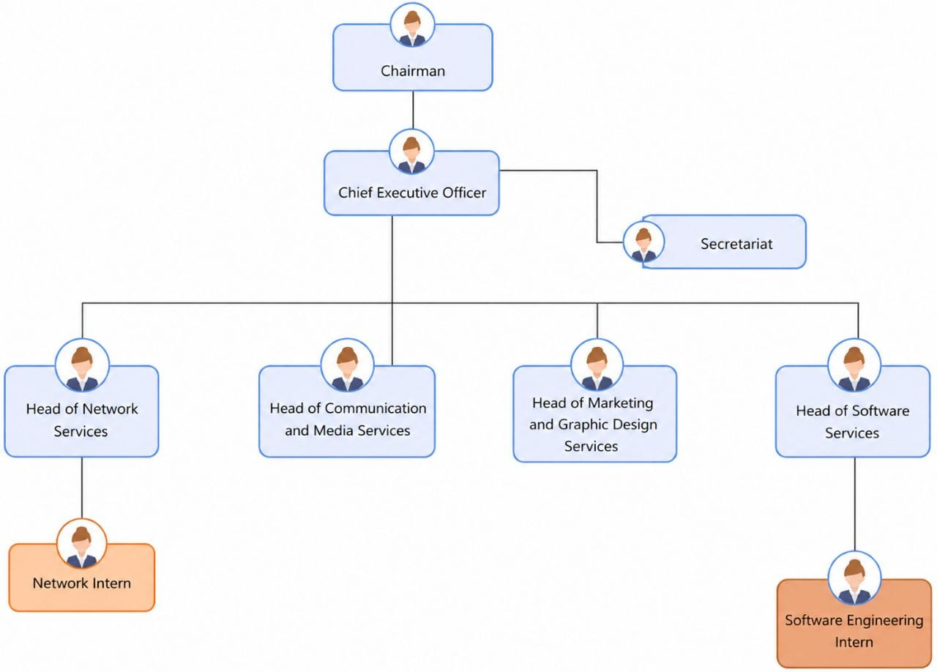
Figure 1: Mercy Innovative Tech Organizational Chart

IV. GEOGRAPHICAL LOCATION

Figure 2: Mercy Innovative Tech Geographical Location (Source : EdrawMax)

V. HARDWARE AND SOFTWARE RESOURCES
The effective operation of Mercy Innovative Tech relies on a combination of hardware and software resources that support software development, training, communication, and administrative activities. These resources provide the technical infrastructure required for the design, implementation, testing, and deployment of digital solutions. The following tables present the main hardware and software resources available within the company during the internship period.

HARDWARE RESOURCES

Table 3: Hardware Resource
EQUIPMENT | Quantity | Purpose
NEC Projector | 2 | Used for presentations and training sessions
Solar Equipment | 1 | Ensure service continuity during power outages
Samsung Printer | 1 | Printing documents
MacBook Pro(2017) | 1 | Development workstation
MSI Gaming Laptop | 1 | Development Workstation
IIYAMA Monitor | 1 | Display Workstation
Modems (2 Flybox, 1 Camtel Fiber) | 3 | Internet connectivity
Synology Server | 1 | Files Storage and database management
Network Switch | 1 | Connects network devices
Router | 1 | Network routing and internet access
Canon EOS 700D Camera | 1 | Media capture
IR Night Vision Camcorder | 1 | Video recording
Samsung Laptops | 2 | Development workstations
HP Laptops | 3 | Development workstations
Acer Laptop | 1 | Development workstation
Toshiba Laptop | 1 | Development workstation
Lenovo Laptop | 1 | Development workstation

SOFTWARE RESOURCES

Table 4: Software Resources
SOFTWARE | TYPE | PURPOSE
Windows 11 Pro | Operating System | Development environment
Ubuntu 21/22/23 | Operating System | Software development and server management
Google Cloud Storage (300 GB) | Cloud Storage | File and data storage

VI. BRIEF PRESENTATION OF THE PROJECT THEME
Upon starting my internship at Mercy Innovative Tech, I was encouraged to work on a project that would not only be technically challenging but also have a tangible impact on society. In line with Mercy Innovative Tech’s vision of contributing to sustainable development through innovative digital solutions, I identified an opportunity to design a system that addresses key operational and safety challenges faced by urban communities and public safety stakeholders in Cameroon. The proposed theme: “CONCEPTION AND REALIZATION OF A SMART COMMUNITY PLATFORM FOR REAL-TIME INCIDENT REPORTING (SOS REPORT).”, aims to create a real-time public safety platform capable of monitoring urban security hazards, tracking emergency reports, and automating threat verification. This solution is designed to improve community safety, streamline incident verification, and provide rapid, anonymous reporting tailored to local connectivity and emergency challenges through a minimal-friction architecture. The system consists of several integrated components:
- A Mobile Application (Flutter): Running on citizens' smartphones to capture location-based incident data, support express sub-second reporting via categorized and neutral interfaces, and display real-time safety maps and geofenced alerts (1–2 km radius).
- A Multimodal AI Engine (Google Gemini 3.5 Flash API): Integrated into the backend to automatically categorize reported threats, evaluate media-to-category consistency, detect false reports, and protect citizen privacy through automated facial and license plate anonymization.
- A Central Administrative Web Dashboard (Laravel + Livewire 3 + Tailwind CSS): For system administrators and local community leaders to monitor live incident heatmaps, review contested reports, manage user Trust Scores, and coordinate local safety responses.
. By combining instant cloud AI verification with community-based confirmations (upvotes/downvotes from nearby users) and dynamic phone-number-based Trust Scores, the system accurately filters out spam and false alerts without requiring complex user registration or compromising reporter anonymity.

CONCLUSION
The insertion phase at Mercy Innovative Tech provided a valuable foundation for this work. This initial experience allowed me to quickly adapt to the professional environment and company culture. During this phase, I gained a deeper understanding of Mercy Innovative Tech’s mission, particularly its focus on innovative and scalable software solutions and the development of highly skilled software engineering and network administration professionals. The welcoming atmosphere fostered collaboration, open communication, and knowledge sharing between the staff and interns. This environment reinforced my motivation to contribute effectively to the company’s goals. Following this brief but insightful phase, I selected the project theme: “CONCEPTION AND REALIZATION OF A SMART COMMUNITY PLATFORM FOR REAL-TIME INCIDENT REPORTING (SOS REPORT).” This theme aligns with Mercy Innovative Tech’s commitment to delivering impactful technology that addresses critical societal needs in public safety and emergency management. Having established a clear project direction, I am now prepared to proceed to the study of existing systems to identify gaps and opportunities for improvement.

PHAE

PHASE TWO: TECHNICAL PHASEPHAE

PHASE TWO: TECHNICAL PHASE

Preamble

The technical phase is a document that describes the process, progress, or results of a scientific research. It also includes a detailed analysis and the conclusions drawn from that research.
Content

VI.

VI.

FILE 7: INSTALLATION GUIDE AND USER GUIDE

FILE 7: INSTALLATION GUIDE AND USER GUIDE
FILE 1: THE EXISTING SYSTEM

FILE 1: THE EXISTING SYSTEM
FILE 2: THE SPECIFICATION BOOK

FILE 2: THE SPECIFICATION BOOK
FILE 3: THE ANALYSIS PHASE

FILE 3: THE ANALYSIS PHASE
FILE 4: CONCEPTION PHASE

FILE 4: CONCEPTION PHASE
FILE 5: REALIZATION PHASE

FILE 5: REALIZATION PHASE
FILE 6: TEST OF FUNCTIONALITIES

FILE 6: TEST OF FUNCTIONALITIES

FILE 1: THE EXISTING SYSTEM

Preamble

The existing system is a file that provides a view of how the current system of study works, that is, outlined how the different activities are carried out, and also provides a deep understanding of this system and the limitations it faces, the problem resulting from these and the solution we propose.
Content

INTRODUCTION

INTRODUCTION

I.

I.
PRESENTATION OF THE PROJECT THEME

PRESENTATION OF THE PROJECT THEME

II.

II.
DESCRIPTION OF THE EXISTING SYSTEM

DESCRIPTION OF THE EXISTING SYSTEM

III.

III.
CRITICISMS OF THE EXISTING SYSTEM

CRITICISMS OF THE EXISTING SYSTEM

IV.

IV.
PROBLEMATIC

PROBLEMATIC

V.

V.
PROPOSED SOLUTION

PROPOSED SOLUTION

CONCLUSION

CONCLUSION

INTRODUCTION
As Software Engineers, our role is to solve societal problems by bringing digital solutions that will hinder life easier for everyone. To develop these effective solutions, we must first ask ourselves critical questions that will help us to understand why the problem exists and how it is currently being addressed, these are the key points the existing system analysis aims at targeting for us to ensure the proposal of solutions that will improve or replace the current system for a better one.

PRESENTATION OF THE PROJECT THEME
Our project theme is “CONCEPTION AND REALIZATION OF A SMART COMMUNITY PLATFORM FOR REAL-TIME INCIDENT REPORTING (SOS REPORT)”. The mobile application aims to provide citizens and emergency services with a centralized, AI-driven platform to report, moderate, and track local incidents rapidly. In the current landscape of urban security, traditional emergency response mechanisms face challenges related to communication latency, inaccurate incident descriptions, and false emergency report (pranks). SOS Report addresses these challenges by offering a scalable solution that utilizes spatial databases and artificial intelligence to send alerts with proofs to the adequate emergency services.

DESCRIPTION OF THE EXISTING SYSTEM
Case study: The Fire Station of Mimboman and the 16th District Police Station at Mimboman Chateau neighborhood

Fire Station Current System
At the Fire Station of Mimboman, incidents are reported either by going at their station and verbally describing it or by calling the official phone number “118” and describing the situation. Once they receive the call and description of the incident, they listen to the background sound (or voices) and wait for any 2 or more reporting of that same incident, before they go on the field for intervention.

The 16th District Police Station Current System
At the 16th District Police Station, incidents are reported either by going at their station and verbally describing it or by calling the official phone number “117” or their private phone number, and describing the situation. Once they receive the call and description of the incident, they go directly on the field for intervention.
The current emergency reporting system in many urban areas in Cameroon relies heavily on classical phone calls to centralized dispatch centers.
- Citizens witnessing or experiencing a danger must manually dial emergency numbers and verbally describe the situation, verify their identity, and explain their location.
- Operators must manually log the details, attempt to verify the authenticity of the call, and dispatch the appropriate units.
- Communication between witnesses and responders is strictly linear and lacks visual or spatial context.
There are also other systems that help in the reporting of incidents; we can find
- SOS Cameroon: a unique safety app that uses SMS t bridge communication and safety across multiple devices. It enables critical emergency alerts and location sharing, regardless of the internet connectivity its functionalities are the following:
- Alert transmission to your predefined contacts in case of an emergency
- Tracking of the current devices, if the phone has been stolen or lost.
- Safety checking features, allowing remote monitoring and localization of nearby hospitals or services stations in case of danger;
- Customized features such as shaking phone, voice note or clicking on a large SOS button to alert loved ones in case of danger.
Target users: any Cameroonian

- Dakar Safe: a community platform for reporting security incidents in Dakar. It allows citizens to report, view and react to security incidents in their neighborhood. Its functionalities include:
- Alerts transmission when the user enters a high-risk area or when incidents are reported in their neighborhood.
- Community moderation system for votes confirmation or false incidents
- Report form for incidents
- SOS report button for emergency incidents
- Personal medical information push to emergency services in case of an SOS alert (with the users concerns)
Target users: citizens of Dakar in the Senegal country.

CRITICISMS OF THE EXISTING SYSTEM
The manual and voice-based emergency reporting system presents significant limitations that hinder rapid intervention:
Table 5: Criticism Table
LIMITATIONS | CONSEQUENCE | PROPOSED SOLUTION
Most of the actual software systems mostly focus on self-emergency reporting | The public services still rely on traditional incident reporting methods for other kind of emergency, and obviously are still highly vulnerable to wastage of time and resources when encountering false reporting. | A system that permits a global possibility of reporting incidents based on the category of problem encountered
Lack of Visual Evidence: | Low trust or risk of doubt on the incident reported | Reporting system based on uploading of photo, short videos for visual proof.
Vulnerability to False reporting (pranks): | Services such as firefighters and police take more time for reactivity. | A system of Trust score per citizen, enhancing the effectiveness of reactivity when the score of the reporter is high
Inaccurate Geolocation from callers in distress often struggling to provide precise addresses | More time spend in analysis to locate the exact incident location. | GPS coordinates are sent alongside the report, hindering the localization easier
More time taken to search and catch prankers after an intervention on a false reporting. | Many prankers still escape the services vigilance and time wasted to track them indirectly | The system automatically keeps Track of every device sending a report

PROBLEMATIC
In high-stress emergency situations, efficient report of the problem and immediate decision taken by public services are vital for citizen survival. However, the current verbal and phone call systems increase administrative workload and slows down the effective intervention the requested services. Given these critical flaws, the fundamental question arises: HOW CAN WE HELP THE PUBLIC SERVICES TO PERFORM A MORE RAPID INTERVENTION WHEN AN INCIDENT IS REPORTED?

PROPOSED SOLUTION
To overcome the inefficiencies of the current system, we propose the development of SOS Report; a comprehensive mobile community platform designed to modernize incident reporting.
- For the Citizen: A cross-platform Flutter application that authenticates with 6-digit Twilio OTPs, features a single-tap SOS trigger recording 5s of ambient audio, automatically captures satellite coordinates, and transparently falls back to background GSM SMS if offline.
- For the Emergency Services (Police, Fire, Medical): Role-specific Livewire web dashboards displaying real-time incident queues, AI trust evaluations, clickable maps, and dedicated "Mark as RESOLVED" and "Mark as FALSE ALERT" toggle buttons that dynamically adjust citizen trust scores.
- For the Central System Administrator: An overarching command center with system configuration, user auditing, override validation buttons, and exclusive interactive controls to unblur and reblur citizen faces on evidence media.

CONCLUSION
The study of the existing system is a crucial step in the development of a digital solution. Taking the time to observe and understand the actual flow of a particular system, the output result, the weaknesses, challenges of this one, permits the developer have a proper foundation for the conception and realization of a new and better system, which is exactly at what aims the file of the existing system.

FILE 2: THE SPECIFICATION BOOK

Preamble

The Specification Book is a document created between the client and the developer to define what the product must do and how it should behave. It guides the development process by outlining all the required features, goals, and constraints. For this project, it serves as a reference for building an AI voice agent platform for interview preparation. Its purpose is to ensure that the final product meets user needs and follows clear, agreed-upon expectations throughout the development phase.
Content

DELIVERABLES

INTRODUCTION

INTRODUCTION

I.

I.
CONTEXT AND JUSTIFICATION OF THE PROJECT

CONTEXT AND JUSTIFICATION OF THE PROJECT

II.

II.
OBJECTIVES OF THE PROJECT

OBJECTIVES OF THE PROJECT

III.

III.
EXPRESSION OF NEEDS

EXPRESSION OF NEEDS

IV.

IV.
PROJECT PLANNING

PROJECT PLANNING

V.

V.
ESTIMATED COST OF THE PROJECT

ESTIMATED COST OF THE PROJECT

CONCLUSION

CONCLUSION
VI.

VI.
VII.

VII.
PROJECT CONSTRAINTS

PROJECT CONSTRAINTS

INTRODUCTION
The specification document for our report serves to clarify our theme, enhancing our understanding and increasing the chances of its success. To define the project's scope, we will outline the context of our theme. From this context, we will identify the specific problems we aim to address throughout the project. After presenting our proposed solution, we will discuss the objectives we have established for the project. We will also examine the needs our system will fulfill, considering both functional and non-functional aspects. Next, we will assess the estimated financial resources required for our project and outline a timeline to ensure we complete it on schedule. Finally, we will address the expectations for our project deliverables by the end of the project.

CONTEXT AND JUSTIFICATION OF THE PROJECT

Context
In a context where urban insecurity is rising, citizens are frequently exposed to dangerous situations where traditional means of seeking help are insufficient. The lack of an integrated digital platform results in delayed responses and an uninformed public. We can have the following results of researches undertaken on these situations:
"Road traffic crash mortality in Southwest Cameroon: a multicenter hospital study." Published in 2025/2026 (PubMed record PMID: 42318574; PMC ID: PMC13272510; the PMC and PubMed by Otang Thierry Otang, Nana Theophil Chunteng, Brandon Carl Monika Pouekoua, Leslie Tasha Mbapah, Ernest Kikah Ndifor, Ngomba Divine Martin Mokake, Alain Chichom Mefire) . What the abstract states: “a five-year retrospective study (Jan 2020–Dec 2024) across three regional referral hospitals in Southwest Cameroon, 3,266 RTC admissions (“Results” paragraph 3 line 1)., 153 in-hospital deaths (4.7% mortality); on multivariable analysis, delayed presentation of 30–60 minutes was independently associated with a doubling of mortality risk (“Results” paragraph 3 line 4)”.
“Cameroun : Incendie meurtrier à Yaoundé - Une mère et ses cinq enfants périssent à Etoa Meki” AllAfrica (republishing Cameroonian press), dated 20 February 2026. Located in the section titled “Une tragédie qui interroge sur les délais d'intervention”, states firefighters arrived only after the house was already fully destroyed.

Justification
The implementation of a mobile application like SOS Report is justified by the urgent need to reduce reaction time of these Emergency services when an incident is reported, thus, reducing the rate of mortality during domestic fire catch, road incident and any other incident involving human life. By leveraging modern technologies such as Flutter for cross-platform accessibility and AI for instant validation, this system will empower citizens, reassure users through real-time community monitoring, and optimize the deployment of emergency services.

II. OBJECTIVES OF THE PROJECT

General Objective
The conception, realization and deployment of an end-to-end digital emergency reporting system that will link both citizens via a quick access platform (mobile app) to public emergency services via a proper monitoring interface (web platform), and will guarantee instant, geolocated alert delivery across both online cloud and offline GSM cellular networks in Cameroon.

Specific Objectives
- Develop a Flutter mobile app capable of locking satellite coordinates and capturing 5 seconds of ambient audio upon SOS trigger.
- Implement a 6-digit SMS OTP authentication workflow using Twilio's API, tailored for Cameroon MTN and Orange numbers (+237),
- Architect a resilient dual-mode dispatch logic: attempting high-speed cloud upload with a 3-second timeout, falling back automatically to direct background GSM SMS.
- Integrate Google Gemini 3.5 Flash to parse emergency media, resolve Cameroonian neighborhoods, compute an AI credibility score (0–100%), and detect screen recaptures.
- Synthesize automated bilingual voice phone calls and instant SMS dispatches via Twilio.
- Implement automated AI face detection and frosted-glass privacy blurring on photos and videos, granting exclusive unblur/reblur rights to the System Administrator.
- Architect a dynamic public emergency service registration system with an unconstrained Admin Service Naming Engine for custom agency creation.
- Build specialized web dashboards for Police, Fire, Medical, and Administrative authorities with Livewire 3 and PostGIS GiST spatial indexing.

III. EXPRESSION OF NEEDS

Functional Needs
These are the requirements that a system must meet to fulfill its purpose, that is, what the SOSReport system should accomplish. The main modules and functionalities include:

Table 6: Functional Needs
Actor | What They Must Be Able to Do in The System
Visitor | - Create an Account
Citizen | - Authenticate  - Report Incident via SOS button  - Report Incident via Standard carousel buttons  - Receive local danger alerts  - Consult heat map  - Consult Incident Details  - Contest nearby incident  - Confirm nearby incident  - Manage their profile
Emergency Services | - Authenticate  - Register an Account  - Consult blurry photo  - Consult blurry video  - Listen to audio  - Consult Trust Score  - Consult GPS coordinates  - Mark incident as Resolved  - Mark incident as False Alert  - Receive local danger alerts  - Consult heat map  - Manage their profile
System Administrator | - Authenticate  - Consult blurry photo  - Consult blurry video  - Listen to audio  - Consult Trust Score  - Consult GPS coordinates  - Unblur faces  - Override to Mark incident as Validated  - Override to Mark incident as False_Alert  - Receive local danger alerts  - Consult heat map  - Manage their profile  - Delete user account  - Suspend user account  - Ban user account  - Consult user account  - Consult system analytics

Non-Functional Needs
It specifies the quality attributes of a software system. They judge the software system application based on the system’s requirements, performance, usability, scalability, portability and other non- functional standards that are critical to its success. Failing to meet the non-functional needs can result in the system not fulfilling the user’s needs.
- High Performance and Low Latency: Gemini API analysis and response time should be very low, and the system must handle offline failover when no internet available.
- Fault Tolerance and Offline Resilience: The mobile app must not crash on network timeouts, null coordinates, or microphone permission denials.
- Data Security: The system should perform protection of sensitive information from unauthorized access
- Scalability: The system should be capable of handling over 1,000 concurrent mobile connections and processing 500 reports/hour.
- Emergency effectiveness: The SOS alert transmission process must execute in under 8 seconds (inclusive of a 3-second safety delay and 5-second environmental capture).
- Usability: The system should have an intuitive and user-friendly interface, and passive legal deterrence message must be permanently visible on the reporting UI to prevent abuse.
- Availability: The application must cache data locally if the internet connection drops, retrying the upload automatically upon reconnection.
- Security and Law: Device IDs and phone numbers must be securely logged to allow administrators to track and ban malicious users.

IV. PROJECT PLANNING
We began our internship on the 6th of July, till the 30th of September 2026. Management of work time was a key habit so as to finish the project within the given period. This section presents how the work phases were scheduled throughout the internship period.

A. Chronogram of Activities
Table 7: Chronogram of activities
Phase | Task Description | Duration | Period
INSERTION | Enterprise Insertion Phase | 14 days | 6th July – 19th July 2026
EXISTING SYSTEM | Existing System Study with Field Survey | 5 days | 20th July – 24th July 2026
SPECIFICATION BOOK | Specification Book Treatment | 11 days | 25th July – 4th August 2026
ANALYSIS | Analysis of the solution and drafting of the analysis document | 20 days | 5th August – 24th August 2026
CONCEPTION | Drafting of the Conception Book | 10 days | 25th August – 3rd Sept 2026
REALIZATION | Realization Phase | 18 days | 4th Sept – 21st Sept 2026
TEST OF FUNCTIONALITIES | Testing of the software and debugging | 5 days | 22nd Sept – 26th Sept 2026
INSTALLATION AND USER GUIDE | User Guide & Final Report drafting | 4 days | 27th Sept – 30th Sept 2026

B. Gantt Project planning

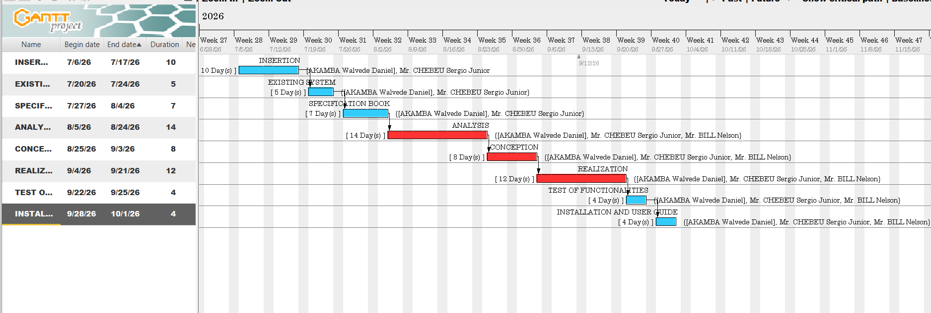
Figure 3: Gantt Project Planning

V. ESTIMATED COST OF THE PROJECT

A. Software Resources
For the realization of this project, we will need the following software applications:
Table 8: Software Resources (source: https://www.microsoft.com/en-us/d/windows-11-pro/dg7gmgf0d8h4)
Software Designation | Description | Quantity | Subtotal (FCFA)
Windows 11 Pro License | Operating System Environment | 1 | 120,000
Visual Studio Code | Code development tool | 1 | Freemium
Visual Paradigm Academic | System Modeling Tool | 1 | Freemium
Microsoft office 365 | productivity suite, useful for editing; documents, spreadsheets, presentations and emails | 1 | 47,998
Twilio Telephony Trial | Voice Call & SMS Dispatch API | 1 | 10,000
Google Gemini API Tokens | Multi-modal Vision & Spatial Triage | 1 | 25,000
TOTAL SOFTWARE RESOURCES |  |  | 202,998 FCFA

B. Hardware Resources
Table 9: Hardware Resources
Hardware Designation | Technical Specifications | Quantity | Unit Cost (FCFA) | Subtotal (FCFA)
Development Workstation | Core i7, 32GB RAM, 1TB SSD | 1 | 450,000 | 450,000
SIM Cellular Test Cards | MTN Cameroon and Orange Cameroon 4G SIMs | 1 | 1,000 | 1,000
Cellular Internet Subscriptions | Orange 20GB High-Speed Bundles | 3 months | 19,000 | 57,000
AWS Server | t3.micro/t4g.micro, 1 Go RAM | 3 months | 6,000 | 18,000
TOTAL HARDWARE RESOURCES |  |  |  | 526,000 FCFA

C. Human Resources
Table 10: Human Resources
Professional Role | Daily Rate (FCFA) | Duration | Subtotal (FCFA)
Project Manager | 65,000 | 30 days | 1,950,000
Backend Developer | 55,000 | 28 days | 1,540,000
Mobile Flutter Developer | 50,000 | 28 days | 1,400,000
Analyst | 100,000 | 20 days | 2,000,000
Tester | 50,000 | 5 days | 250,000
TOTAL HUMAN RESOURCES |  |  | 7,140,000 FCFA

Global Project Budget Summary
Table 11: Estimation cost of project
Cost Category | Amount in FCFA
Total Software Resources | 202,998 FCFA
Total Hardware Resources | 526,000 FCFA
Total Human Resources | 7,140,000 FCFA
Subtotal Direct Costs | 7,868,998 FCFA
Unexpected charges (10%) {(Total cost) * 10%} | 786,899.8 FCFA
OVERALL ESTIMATED BUDGET | 8,655,897.8 FCFA

List Of Participants
The table below presence the different persons who took part in the accomplishment of this project. They include:
Table 12: List of participants
Names | Function | Role
Mr. CHEBEU Sergio Junior | Follows up interns at the Company level | Professional Supervisor
Mr. BILL Nelson | Follows up student at the Academic level | Professional Supervisor
Mr. AKAMBA Walvede Daniel | Second year student at AICS-Cameroon | Project head, analyst, conception and coding of project, testing

VI. PROJECT CONSTRAINTS
To put in place this application, we must respect three main constraints which includes:
- Time: The MVP must be developed, tested, and deployed within the strict timeframe dictated by the academic defense schedule.
- Technical: Hardware-level triggers (eg, volume buttons) are restricted by mobile OS sandboxing; thus, all panic triggers must be software-based UI elements
- Legal: The application must comply with local laws regarding false emergency reporting, enforced via mandatory UI disclaimers.
- Time Constraint: the complete design, implementation, and realization of this system must respect the dateline attributed to it (3 months) including respecting the fixed objectives of the project.
- Budget Constraint: The completion of this project will involve costs related to human resources, software licenses, hosting services, and development materials. the fixed budget for the realization of this project must be strictly respected.

VII. DELIVERABLES
In project management, a deliverable is any tangible outcome resulting from the completion of a service or task. For the SOSReport project, the key deliverables are:
- The fully functional SOS Report Application (APK for Android).
- The Application Source Code (Frontend and Backend).
- The comprehensive Academic Report
- The User Guide and Installation Manual.
- The PowerPoint Presentation for the academic jury.

CONCLUSION
In conclusion, the specification book has permitted us to present the general and specific objectives of SOSReport, its constraints, its functional and nonfunctional needs, lay out the different resources needed for its realization, and finally the project planning. The end of this document will enable us to now move forward to the Analysis Phase, where we will model the system using appropriate modeling languages and methodologies, to create detailed system designs and conduct a comparative study of these approaches. This analysis will guide the development and ensure that the system meets all outlined requirements effectively.

FILE 3: THE ANALYSIS PHASE

Preamble

The main objective of the analysis file is to capture the user’s need, by detailly breaking down the field of study and to have a clear understanding of the system with the help of diagrams. To achieve this, we will need to choose the best method of analysis to apply for our system.
Content

INTRODUCTION

INTRODUCTION
I.

I.
METHODOLOGY

METHODOLOGY

A. COMPARATIVE STUDY OF UML AND MERISE.

A. COMPARATIVE STUDY OF UML AND MERISE.

D. ACTIVITY DIAGRAM

B. COMPARATIVE STUDY OF UNIFIED PROCESSE

B. COMPARATIVE STUDY OF UNIFIED PROCESSE

II.

II.
MODELLING OF THE PROPOSED SOLUTION

MODELLING OF THE PROPOSED SOLUTION

A. USE CASE DIAGRAM

A. USE CASE DIAGRAM

CONCLUSION

CONCLUSION
B. COMUNICATION DIAGRAM

B. COMUNICATION DIAGRAM

C. SEQUENCE DIAGRAM

C. SEQUENCE DIAGRAM

INTRODUCTION
The realization of a good project is mainly based on its analysis. A poorly analyzed project cannot yield good results. Analysis is the decomposition of a problem into its various elements for computer processing. The main objective of this file is to capture the user's needs, delimit the field of study, and gain a clear understanding of the system being studied. In this section, we will justify our choice of methodology and proceed to modeling the functional requirements of the SOS Report platform.

I. METHODOLOGY
Analysis is the fundamental step in the design of software. It forms the base for the realization of every information system. Several methods and languages have been put in place to facilitate the analysis and design of information systems, mainly MERISE and UML.

A. Comparative Study of UML and MERISE
MERISE and UML both help design information systems, but they differ mainly in what they are and how they represent a system: MERISE is a full analysis-and-design methodology, while UML is a standardized visual modeling language

- MERISE (Méthode d’Étude et de Réalisation Informatique pour les Systèmes d’Entreprise)
It is a structured methodology for analyzing, designing, and implementing information systems, especially databases and business applications. It proposes to consider the real system from two separate points of view:
The Static View (data) which is modeled through three abstraction levels:
- Conceptual Data Model (CDM); what data exists and how it relates (entity–relationship style)
- Logical Data Model (LDM); more detailed, closer to relational structures
- Physical Data Model (PDM); actual database tables, keys, indexes, etc.

And the Dynamic View (treatments). Which is modeled through parallel levels:
- Conceptual Treatment Model (CTM); high-level business processes
- Organizational Treatment Model (OTM); who does what, where, with which resources
- Operational/Physical Treatment Model; concrete workflows, screens, batch jobs, etc.

- UML (Unified Modeling Language):
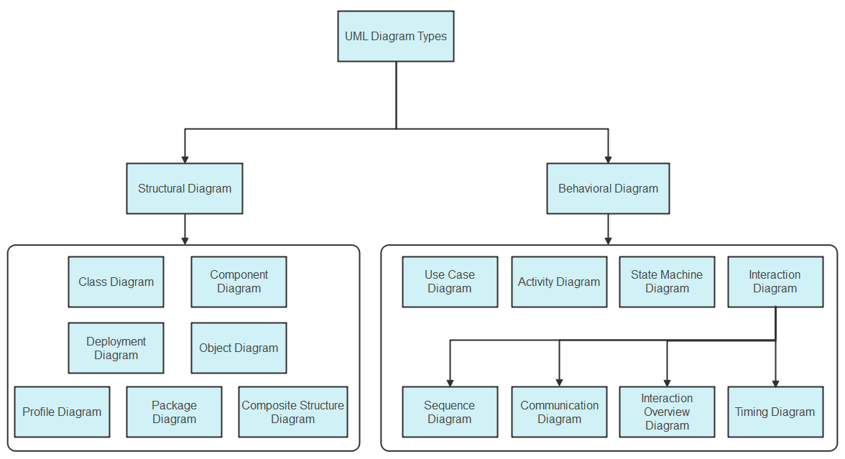
UML is a standard notation for the modeling of real-world objects as a first step in developing an object-oriented design methodology. Unlike MERISE, UML combines data and processing, centralizing the data of a type and the associated processing to limit maintenance points in the code.
Figure 4:UML diagrams (source: https://images.edrawsoft.com/articles/what-is-uml/uml-diagram-types.png)

Table 13: Comparison between MERISE and UML
Point of Comparison | MERISE | UML
Definition | Method of analysis and design for information systems. | Visual modeling language for object-oriented systems.
Approach | Separate data and treatments (procedural approach). | Combines data and processing (object-oriented approach).
Standardization | Mainly used in French-speaking environments. | Internationally recognized standard.
Data and behavior | Separates data models from treatment/process models | Usually, groups data and behavior around objects/classes; a class can define attributes and operations
Modeling progression | Uses abstraction levels such as conceptual, logical, and physical models | Uses different diagrams for distinct views, such as class, use-case, activity, sequence, component, and deployment diagrams
Process modeling | Models’ processes/treatments separately, including conceptual and organizational views | Represents behavior through activity, sequence, state-machine, and use-case diagrams

B. Comparative Study of Unified Processes
Since UML is a modeling language and not a method, it must be associated with a Unified Process (UP) to provide a development framework. 2TUP, short for Two-Track Unified Process, is a software-development process that uses UML; it is not a part or “version” of UML itself. UML supplies the modeling diagrams, while 2TUP supplies the workflow for applying them during a project. 2TUP organizes development around two parallel concerns:
- Functional track: determines what the system must do for users and the business.
- Technical/architecture track: determines how the system will be built: technology choices, architecture, performance, security, deployment, and reusable technical components.
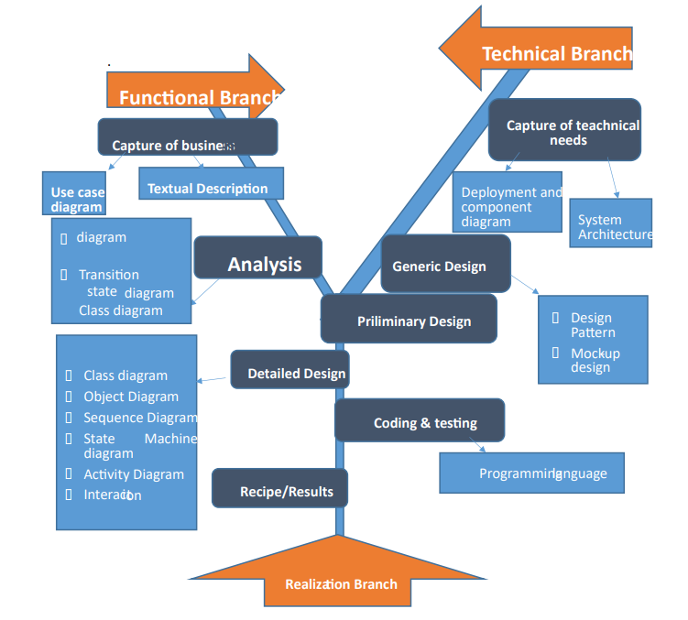
Figure 5: 2TUP diagram (Source: Miss. NYANGONO NDO EMMANUELLA DORETTE EMIE’S Report (session 2024))

Those two tracks later join in a realization phase, producing the familiar Y-shaped development cycle. The separation is intended to handle business changes and technical changes independently until they need to be integrated.

Table 14: Understanding 2TUP branches
Branch | Main question | Typical UML artifacts
Functional branch | “What business services and user outcomes are required?” | Use-case diagrams, activity diagrams, domain/class models, system sequence diagrams
Technical branch | “What architecture and technical services are needed?” | Component diagrams, deployment diagrams, package diagrams, technical class/interface models
Realization branch | “How do we integrate, implement, test, and deliver it?” | Detailed class and sequence diagrams, component designs, test models

Choice of the Analysis Method
The choice should be guided based on the following criteria:
MERISE, when your emphasis is on rigorous business analysis, organizational workflows, and relational database design, particularly in environments already using MERISE conventions; and UML, when you are building object-oriented software and need to communicate software structure, runtime interactions, components, and deployment.
For the SOS Report project, our choice is based on the modeling language UML associated with the 2TUP process due to the following criteria:
- UML is based on the object-oriented approach, which perfectly aligns with our chosen technologies (Flutter and Laravel).
- 2TUP allows for flexibility in project analysis and is highly user-oriented, ensuring the software responds directly to citizen and emergency service needs.
- 2TUP's separation of functional and technical tracks allows us to manage the complexity of integrating spatial databases (PostGIS) and AI APIs (Gemini) without losing focus on the core user experience.

II. MODELING OF THE PROPOSED SOLUTION

A. Use Case Diagram
1. Definition
The use case diagram shows the relationship between the actors of the system and the system itself. It allows us to easily visualize the different actions that can be done by the users and clearly defines the boundaries of the system.

2. Formalism
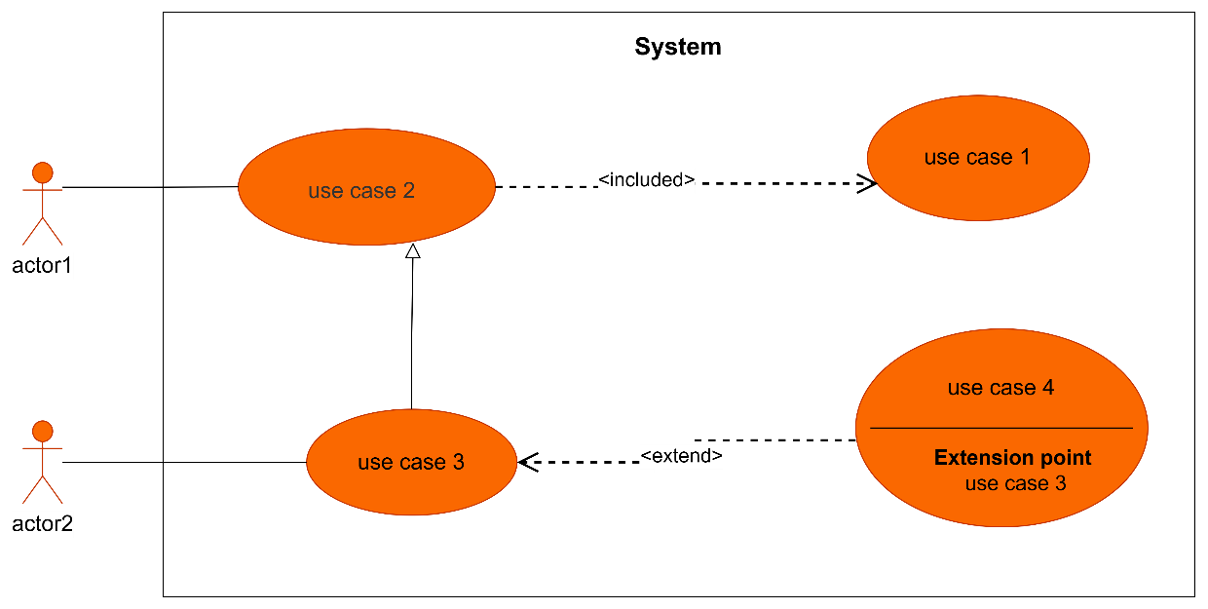
Figure 6: formalism of a use case diagram

3. The Component of the use case Diagram
Table 15: Components of use case diagram
Elements | Representation | Description
Actor | 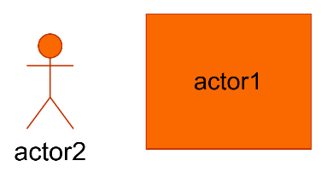 | Represents the entity who directly interacts with the system. The actor is one who performs the different tasks or actions of the system.
Use Case | 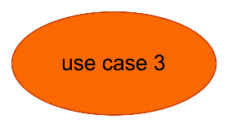 | it represents the functionality of the system. It is an action that an actor can perform
Generalization | 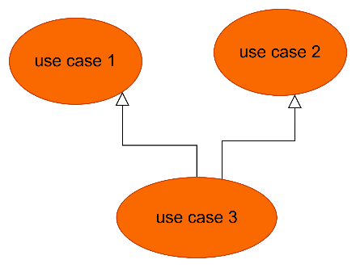 | Generalization is a relationship between a general use case (the parent) and a more specific use case (the child) that inherits and can add to or override the behavior of the parent use case.
Inheritance |  | this is the only possible relationship that can exist between actors whereby an actor can inherit from another
Include | 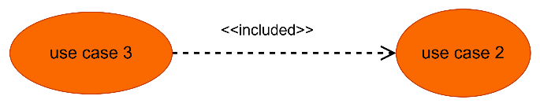 | It denotes that an included action must be performed before another action can be done.
Extend | 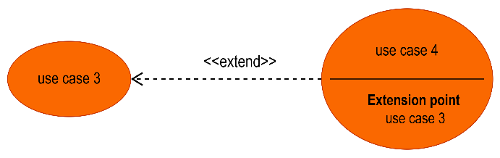 | It denotes that an action may be performed while another action is going on e.g. a use case B extends A implies B is an optional part of A
4. The Actors of our System
Table 16: Actors of our System
Actor | Role in the System
Visitor | An unregistered individual who can access the system to create an account
Citizen | Eyewitness or victim who authenticates, triggers SOS alerts, reports local incidents, consults detailed incident logs and confirm/contest nearby incidents.
Emergency Services | Authorized personnel who receive alerts, inspect alert evidence, update incident statuses to mark them as Resolved or False alert.
System Admin | Supreme gatekeeper auditing registrations, assigning custom service titles, toggling face unblur, executing overrides on AI results, managing user accounts, consulting alert evidence and viewing system analytics.
Gemini 3.5 Flash API | AI service analyzing audio, text, and photos to score citizen’s credibility during an incident report.
Twilio API | Communication gateway responsible for generating and sending SMS OTPs during the authentication process, and also executing automated bilingual voice calls and emergency SMS dispatches.
Firebase Cloud Messaging (FCM) | Notification service that dispatches priority local danger alerts to mobile terminals in affected zones.
Open Street Map | Mapping service providing the visual tiles required to render the spatial heat map.
SMTP Server | A standard mail server used for sending out email-based communications, such as feedback confirmations and other notifications.

General Use Case Diagram of SOS Report
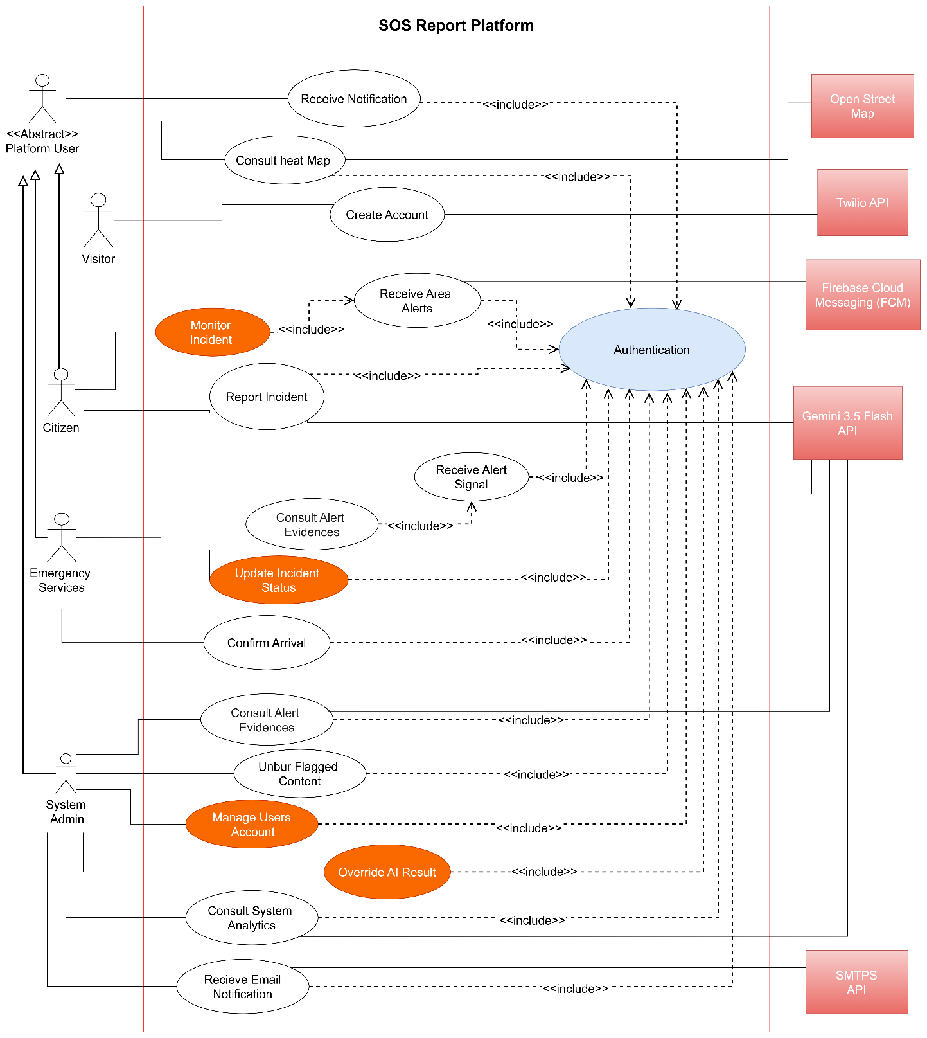
Figure 7: General Use Case Diagram of SOS Report

Specific Use Case Diagrams
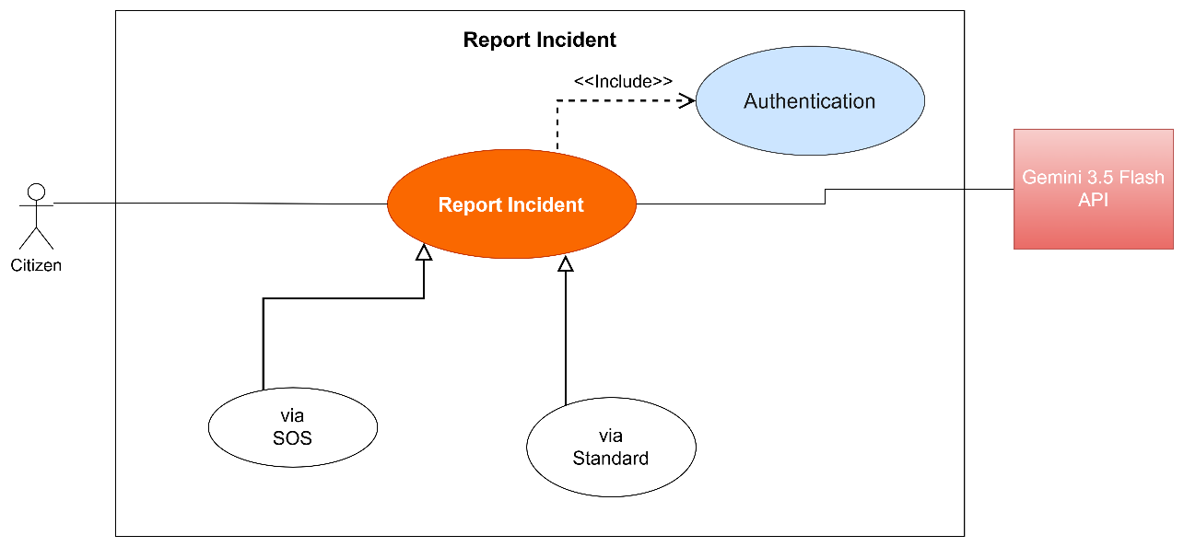
Specific, Use Case of Report Incident

Figure 8: Specific Use Case of Report Incident

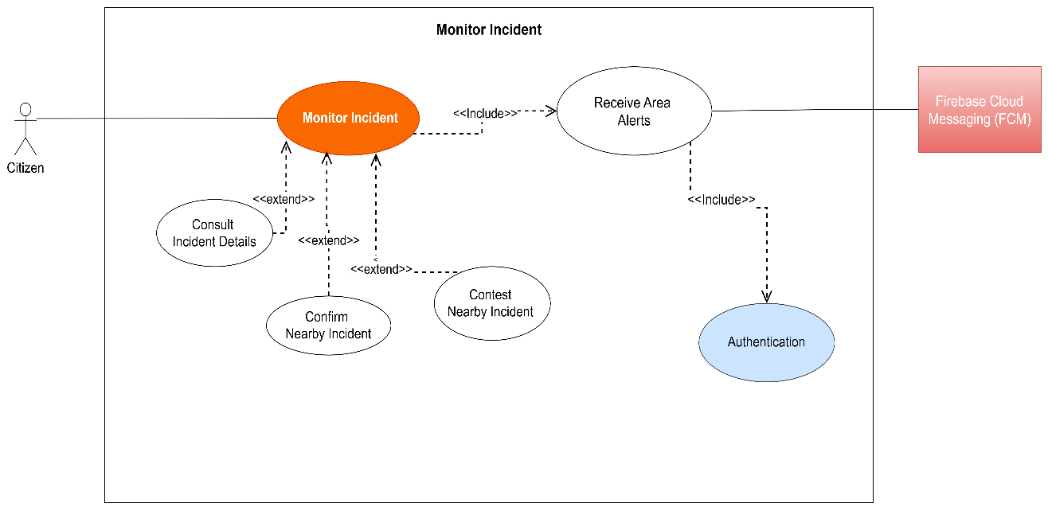
Specific, Use Case of Monitor Incident

Figure 9: Specific Use Case of Monitor Incident

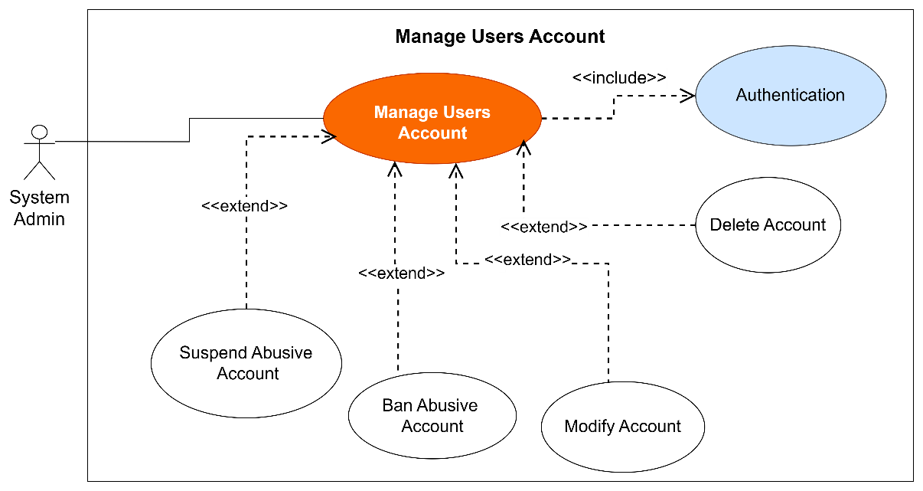
Specific, Use Case of Manage Users Account
Figure 10: Specific Use Case of Manage Users Account

Textual Descriptions of Use Cases
1. Textual Description of << Authentication >>
Table 17: Textual Description of Authentification
Title | Authentication
Summary | This use case allows a Visitor to authenticate via OTP and transition to a Citizen role for elevated platform tracking.
Actors | Visitor, Twilio API
Date | August 9, 2026
Stakeholder | SOS Report Directors
Version | 1.0
Precondition(s) | The app is launched.  The user is on the Authentication interface.
Triggers | The user clicks “Create Account” banner or attempts a restricted action (tries to view an alert’s details when he receives it.)
Nominal Scenarios | 1. User enters Name and Phone Number and submits.  2. The system checks the formatting.  3. The system sends an OTP generation query to the Twilio API.  4. The Twilio API executes the query and sends the OTP via SMS.  5. The user inputs the received OTP and submits the form.  6. The system checks the conformity of the OTP.  7. The system updates the user's role to Citizen in the database.  8. The system displays a successful message to the actor.
Alternative Scenarios | 9. At step 5 of the nominal scenario, the user enters an invalid or expired OTP.  10. The system displays an error message then returns to step 4 of the nominal scenario.
Exception scenarios | The Twilio API is unreachable; the system halts the process and displays a network error message.
Postcondition of success | Citizen role is assigned and the Heat Map is unlocked and dislplayed.
Postcondition of failure | The user does not have access to the Citizen platform and remains a Visitor.
Non-functional requirement | The OTP delivery and verification process must execute in under 30 seconds.

2. Textual Description of <<Report Incident>>
Table 18: Textual Description of Report Incident
Title | Incident Report
Summary | This use case describes the process of reporting a danger (standard media upload or extreme panic via "SOS button"), triggering Gemini AI triage.
Actors | Platform User, Gemini 1.5 Flash API
Date | August 9, 2026
Stakeholder | SOS Report Directors
Version | 1.0
Precondition(s) | The app is launched.  GPS and media permissions are granted.  Legal disclaimer ("Opt-in") accepted in settings for the SOS report access.
Triggers | The user taps the standard report button OR the "SOS" button trigger.
Nominal Scenarios | 1. The system captures the static GPS coordinates and media payload (photo/video/audio).  2. The system sends the data to the backend.  3. The backend sends the serialized data as a request to the Gemini 1.5 Flash API.  4. The Gemini API validates the incident severity.  5. The system saves the incident to the spatial database.  6. The system displays a successful message to the actor.
Alternative Scenarios | 7. At step 1 of the nominal scenario, the user uses the “SOS” button trigger.  8. The screen darkens, vibrates, and starts a 3-second countdown with an “Undo” button.  9. The countdown expires, and the system records 4 seconds of ambient audio and static GPS, proceeding to step 2.  10. (Cancellation): If the user taps "Undo" before 5 seconds, the alert is aborted locally.
Exception scenarios | The user loses GPS signal; the system halts the upload and prompts the user to check location settings.
Postcondition of success | The incident is mapped on the Open Street Map heat map.
Postcondition of failure | The incident is not published to the public heat map.
Non-functional requirement | A passive legal deterrence message (Article of the Penal Code) must be permanently visible on the reporting UI.

3. Textual Description of <<Consult Alert Evidences>>
Table 19: Textual Description of Consult Alert Evidences
Title | Consult Alert Evidences
Summary | Emergency Services review media, AI trust scores, and static GPS coordinates associated with a reported incident.
Actors | Emergency Services
Date | August 9, 2026
Stakeholder | SOS Report Directors
Version | 1.0
Precondition(s) | The actor is authenticated as Emergency Services.  The actor is on the emergency dashboard.
Triggers | The actor clicks on a pending incident from the queue.
Nominal Scenarios | 1. The system sends a query to the database to fetch the incident details.  2. The database executes the query and returns the media, trust score, and static GPS data.  3. The system displays the incident interface.  4. The actor clicks to view a blurry photo, view a video, or listen to audio.  5. The system renders the requested evidence on the screen.
Alternative Scenarios | 6. At step 4, the media payload is corrupted or missing.  7. The system displays a “Media Unavailable” placeholder while successfully displaying the Trust Score and GPS coordinates.
Exception scenarios | The database connection times out; the system displays an error message and prompts a retry.
Postcondition of success | The actor successfully reviews the evidence to make an intervention decision.
Postcondition of failure | The evidence interface fails to load.
Non-functional requirement | The interface must prioritize loading the AI Trust Score and GPS coordinates before the heavy media files.

4. Textual Description of <<Monitor Incident>>
Table 20: Textual Description of Monitor Incident
Title | Monitor Incident
Summary | A Citizen views an incident and confirms or contests it, but only if they are physically closed to the danger zone.
Actors | Citizen
Date | August 9, 2026
Stakeholder | SOS Report Directors
Version | 1.0
Precondition(s) | The user is logged in as a Citizen.  The user has their phone's GPS turned on.
Triggers | The user clicks on a specific incident on the map.
Nominal Scenarios | 1. The system fetches the incident details from the database.  2. The system compares the user's current GPS location with the incident's location.  3. Because the user is nearby, the system shows the “Confirm” and “Contest” buttons.  4. The user clicks the “Confirm” button.  5. The system adds one to the confirmation count in the database.  6. The system shows a success message.
Alternative Scenarios | 7. At step 2, the system sees the user is too far away.  8. The system hides the "Confirm" and "Contest" buttons and shows a message saying "You must be nearby to vote."  9. At step 4, the user decides the alert is fake and clicks "Contest" instead, which lowers the incident's trust score.
Exception scenarios | The internet disconnects when the user clicks the button; the system shows an error and asks them to try again.
Postcondition of success | The incident's community score is successfully updated.
Postcondition of failure | The incident score does not change.
Non-functional requirement | The system must block a user from voting on the same incident more than once.

5. Textual Description of << Receive Area Alerts >>
Table 21: Textual Description of Receive Area Alerts
Title | Receive Area Alerts
Summary | The Platform User receives real-time push notifications about confirmed critical dangers in their vicinity.
Actors | Platform User, Firebase Cloud Messaging (FCM)
Date | August 9, 2026
Stakeholder | SOS Report Directors
Version | 1.0
Precondition(s) | The application is installed on the user's device.  Push notification permissions are granted.
Triggers | The backend publishes a critical incident.
Nominal Scenarios | 1. The spatial database calculates the geographical impact area of the incident.  2. The backend identifies active mobile devices located within this zone.  3. The backend sends a priority notification request to Firebase Cloud Messaging (FCM).  4. FCM delivers the push notification to the targeted devices.  5. The mobile application displays the alert details and safety instructions.
Alternative Scenarios | 6. At step 2, the backend identifies zero mobile devices in the calculated impact area.  7. The system logs the incident without triggering FCM communication.
Exception scenarios | FCM services are temporarily unresponsive; the backend queues the notification for a retry.
Postcondition of success | The user receives the local danger alert on their device.
Postcondition of failure | The user is not notified of the danger.
Non-functional requirement | The data dispatch from the backend to FCM must occur in under 5 seconds.

B. Communication Diagram
1. Definition
The communication diagram is used to model the specific structural interactions between the participants of the system. It describes both the static and dynamic behavior of the system, showing the chronological succession of actions performed by an actor and how objects are linked to realize a specific operation.
2. Formalism
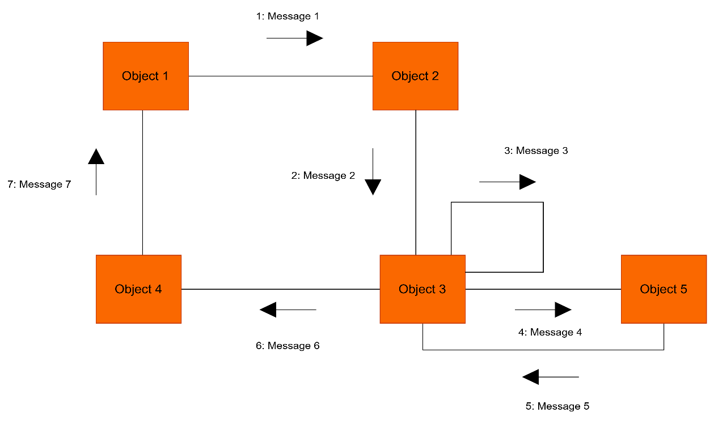
Figure 10: Formalism of a Communication Diagram
3. Components of the Communication Diagram
Table 22: Components of the Communication diagram
Elements | Representation | Description
Object | 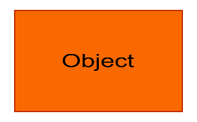 | Represents a role or object instance that participated in the interaction model.
Message | 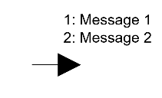 | Defines a particular communication between lifelines in an interaction.
Link | 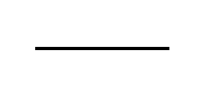 | It connects two objects together for them to communicate
Actor |  | It models the type of role played by an entity that interact with the subject

Communication Diagrams for SOS Report
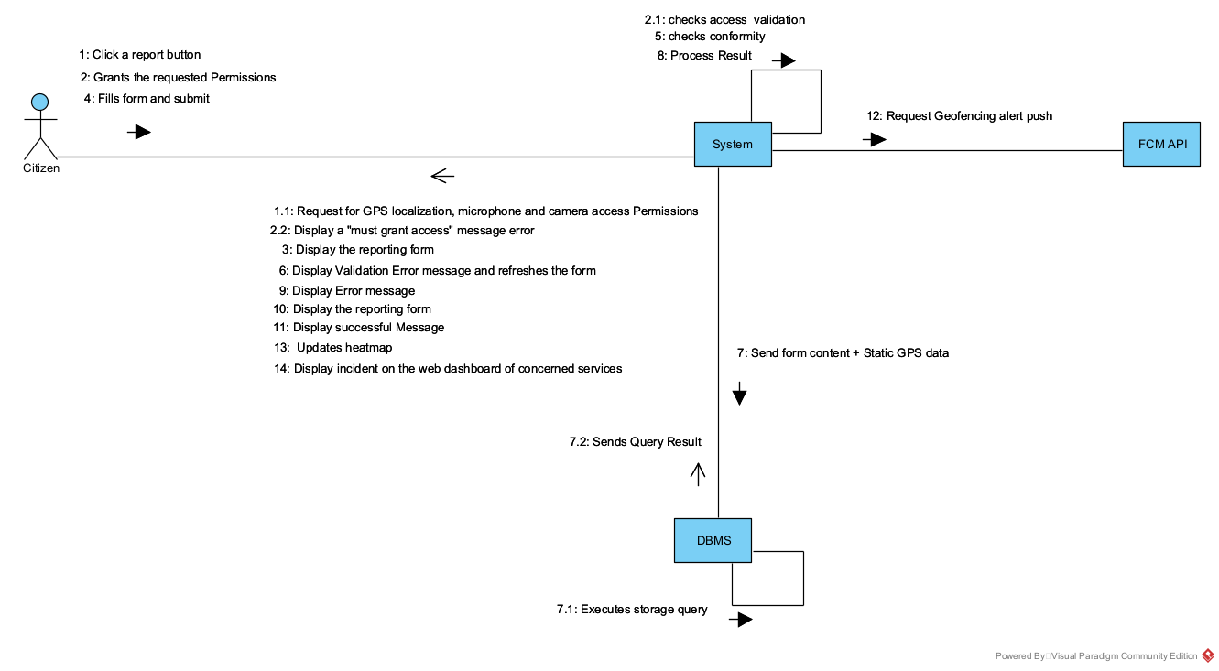
Communication Diagram of Report Incident via Standard Cards
Figure 11: Communication Diagram of Report Incident

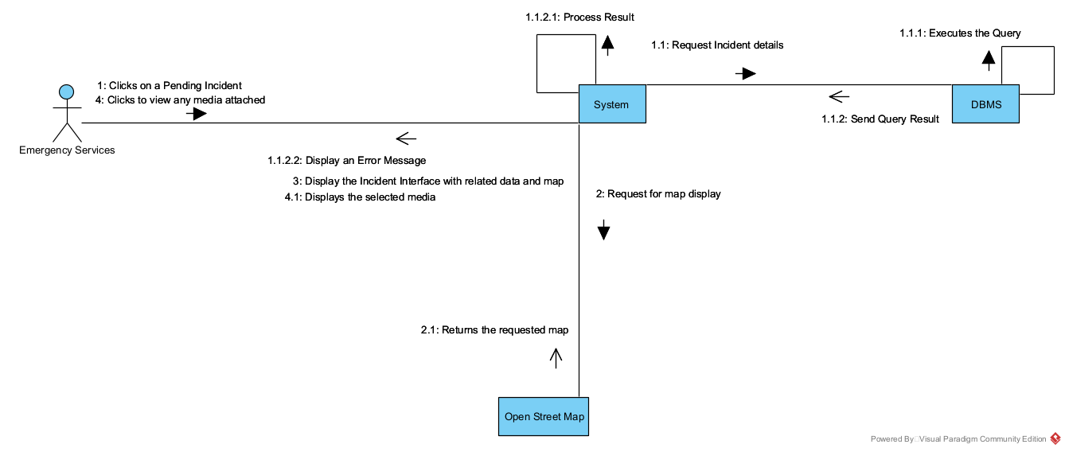
Communication Diagram of Consult Alert Evidences
Figure 12: Communication Diagram of Consult Alert Evidences

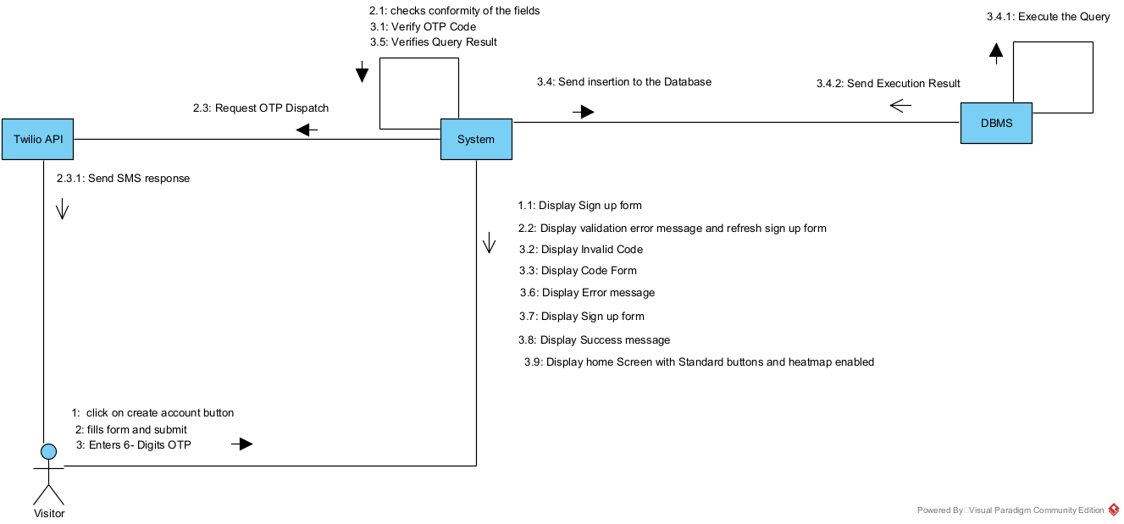
Communication Diagram of Create Account
Figure 13: Communication Diagram of Create Account

C. Sequence Diagram
1. Definition
A Sequence diagram is a UML behavioral diagram that illustrates the sequence of messages exchanged between objects over time. It is essential for visualizing runtime scenarios, validating how the system will behave chronologically, and discovering the specific responsibilities of classes.

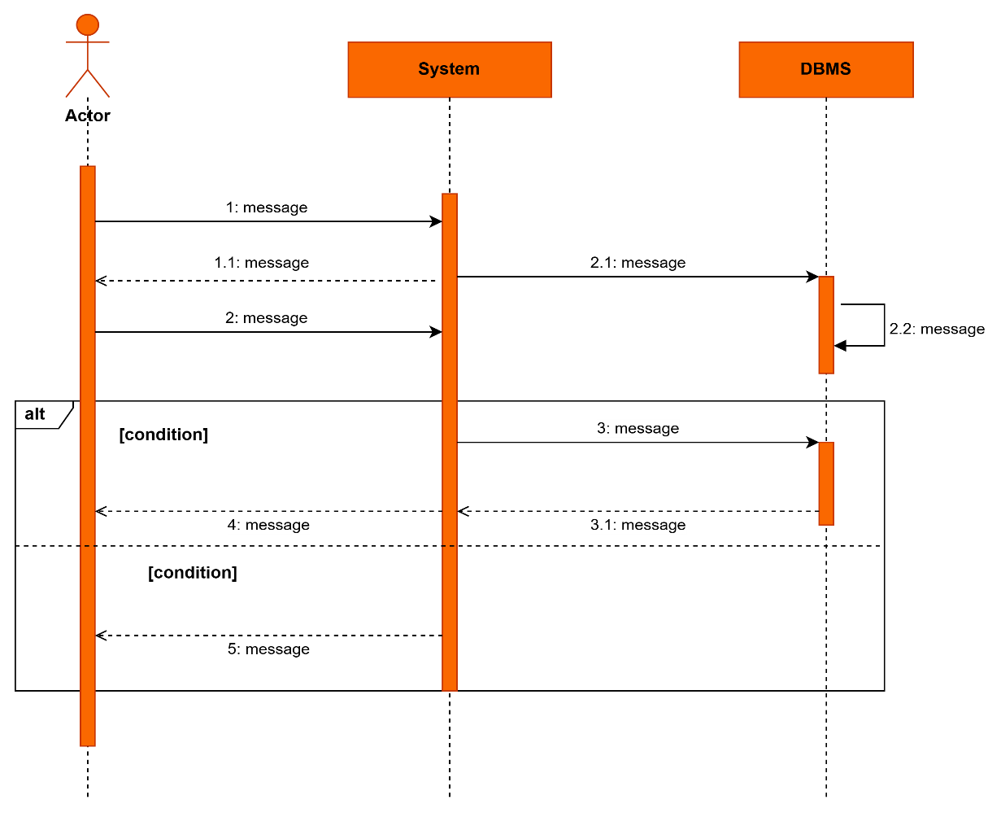
2. Formalism
Figure 14: Formalism of a Sequence Diagram

3. Components of the Sequence Diagram

Table 23: Components of the Sequence diagram
Elements | Representation | Description
Lifeline | 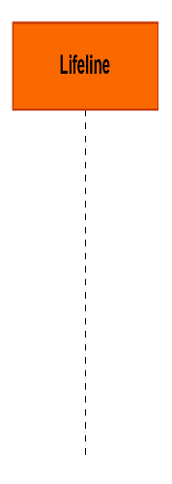 | They represent rows or object instances that participates in a sequence being modeled.
Asynchronous Message | 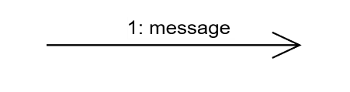 | It is a message that receives an indirect response
Synchronous Message | 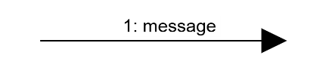 | It is a message that sends and want response before it continues a process
Actor | 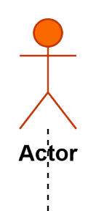 | They send and receive message.
Combined Fragment | 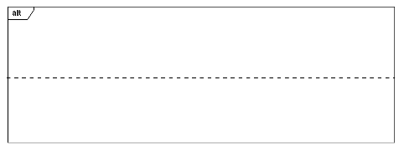 | It represents a choice of behavior in which at most one operand will be chosen.
Self-Message | 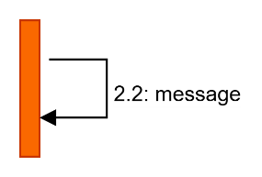 | Represents the execution or operation call on the same object
Return Message | 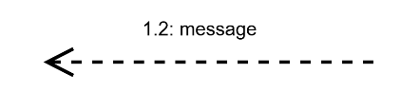 | Represents a response to a message

Sequence Diagrams for SOS Report
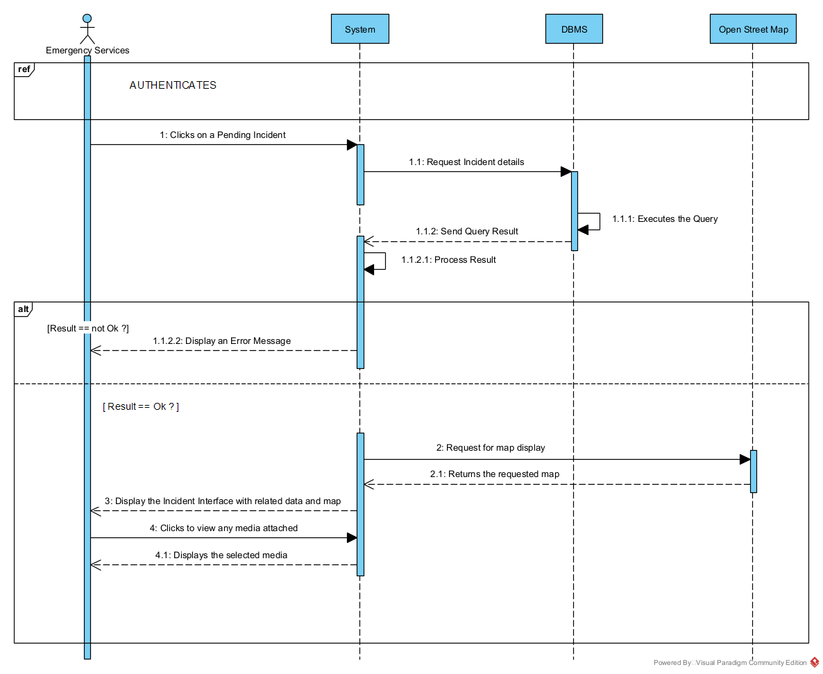
Sequence Diagram for Consult Alert Evidences
Figure 15: Sequence Diagram for Consult Alert Evidences

Sequence Diagram for Report Incident via Standard Cards
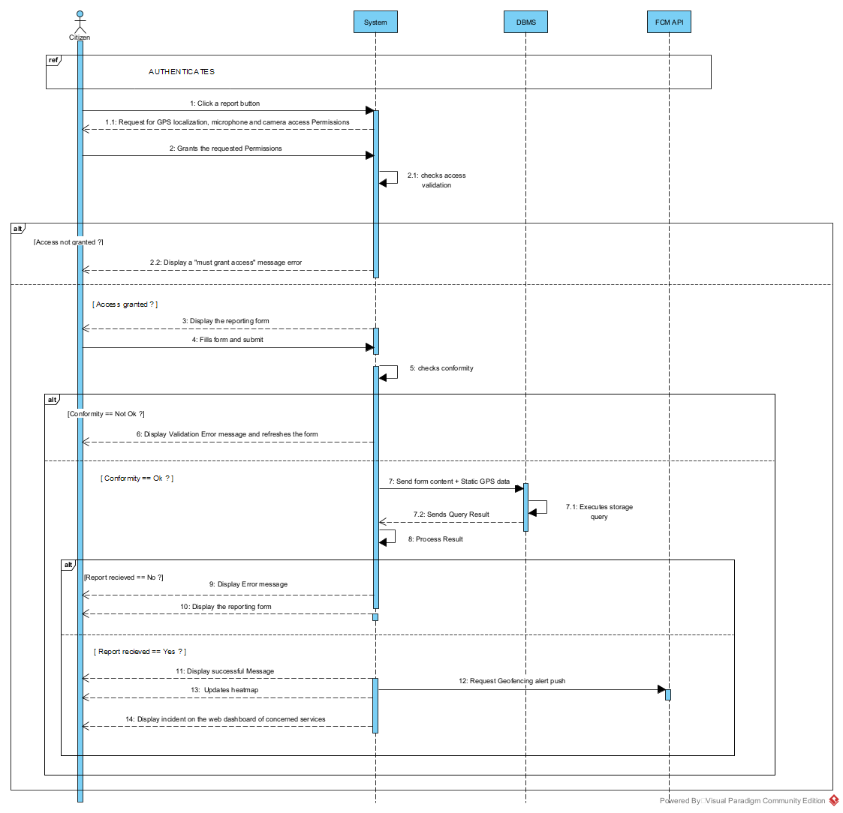
Figure 16; Sequence Diagram for Report Incident

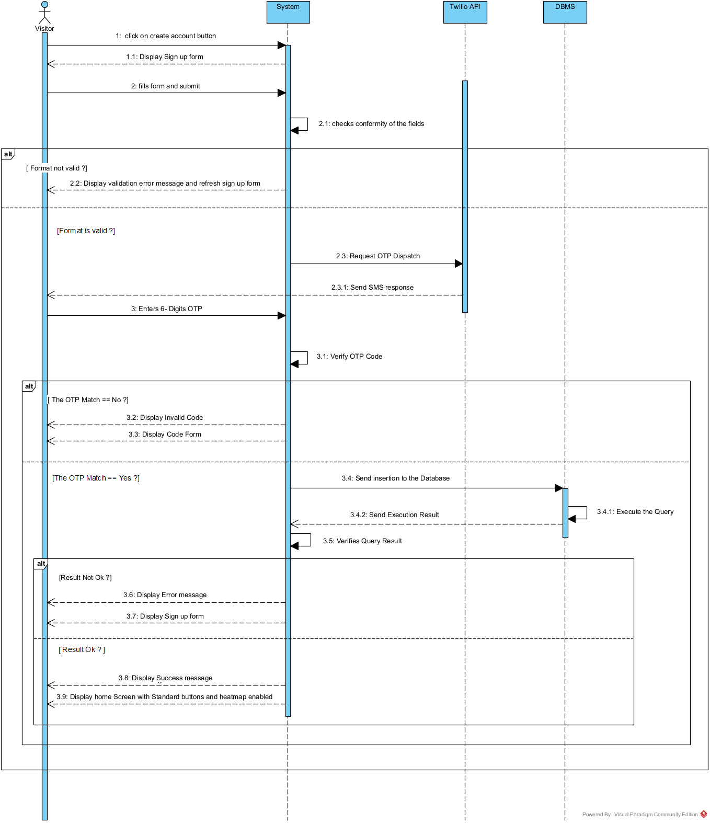
Sequence Diagram for Create Account
Figure 17: Sequence Diagram for Create Account

D. Activity Diagram
1. Definition
An activity diagram provides a visual view of the behavior of a system by describing the sequence of actions and decisions in a process. It formalizes the workflow of a use case, allowing us to map out parallel branches, conditions, and concurrent executions.
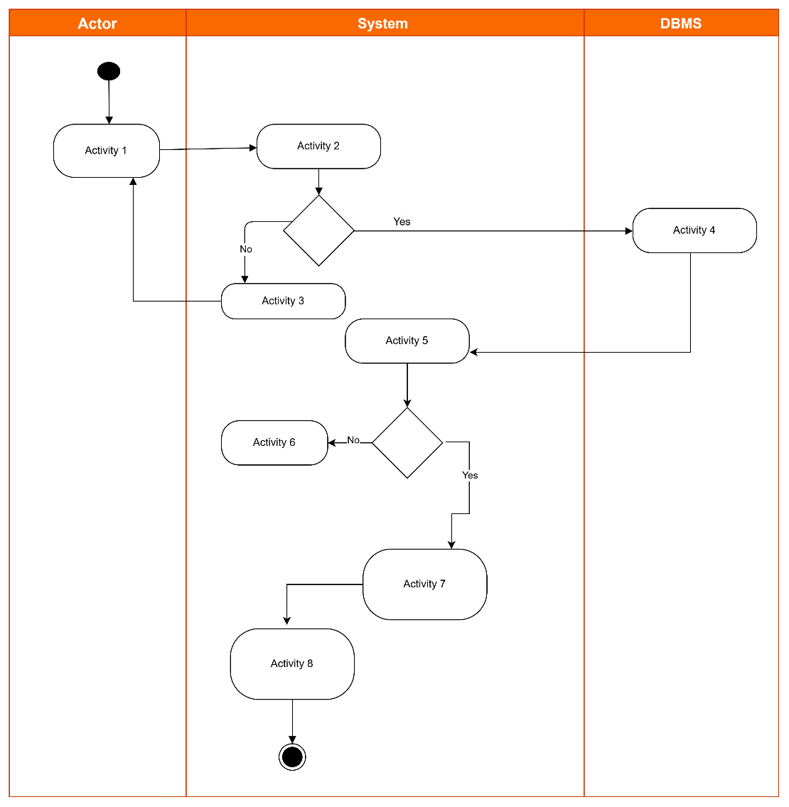
2. Formalism
Figure 18: Formalism of the Activity Diagram

3. Components of the Activity Diagram
Table 24: Components of the Activity diagram
Elements | Representation | Description
Activity | 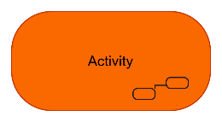 | It describes a complete process composed of several steps (actions) linked together.
Activity edge | 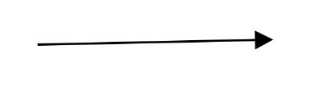 | A directed connection between two activity nodes through which tokens may flow.
Decision node |  | Represents a test condition that slits an incoming activity edge into opposite outgoing activity edges.
Initial Node |  | Shows the beginning of an activity or set of actions.
Final Node |  | Stops all controls and object flows in an activity.
Action | 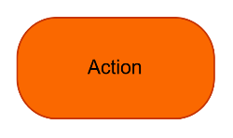 | Represents what the system, an actor or an object does at a given moment.
Merge node | 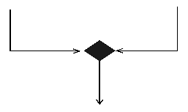 | Reunite different decision paths created using a decision node.
Fork node | 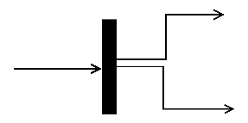 | Slit’s behavior into parallel or concurrent flows of activities (or actions).
Join node | 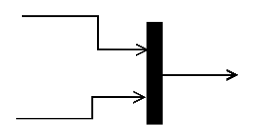 | Unites a set of parallel or concurrent flows of activities or actions
Swimlane and partition | 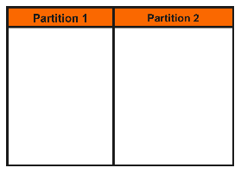 | A way of grouping activities performed by the same actor in an activity diagram or to group actions in the same thread.

Activity Diagrams for SOS Report
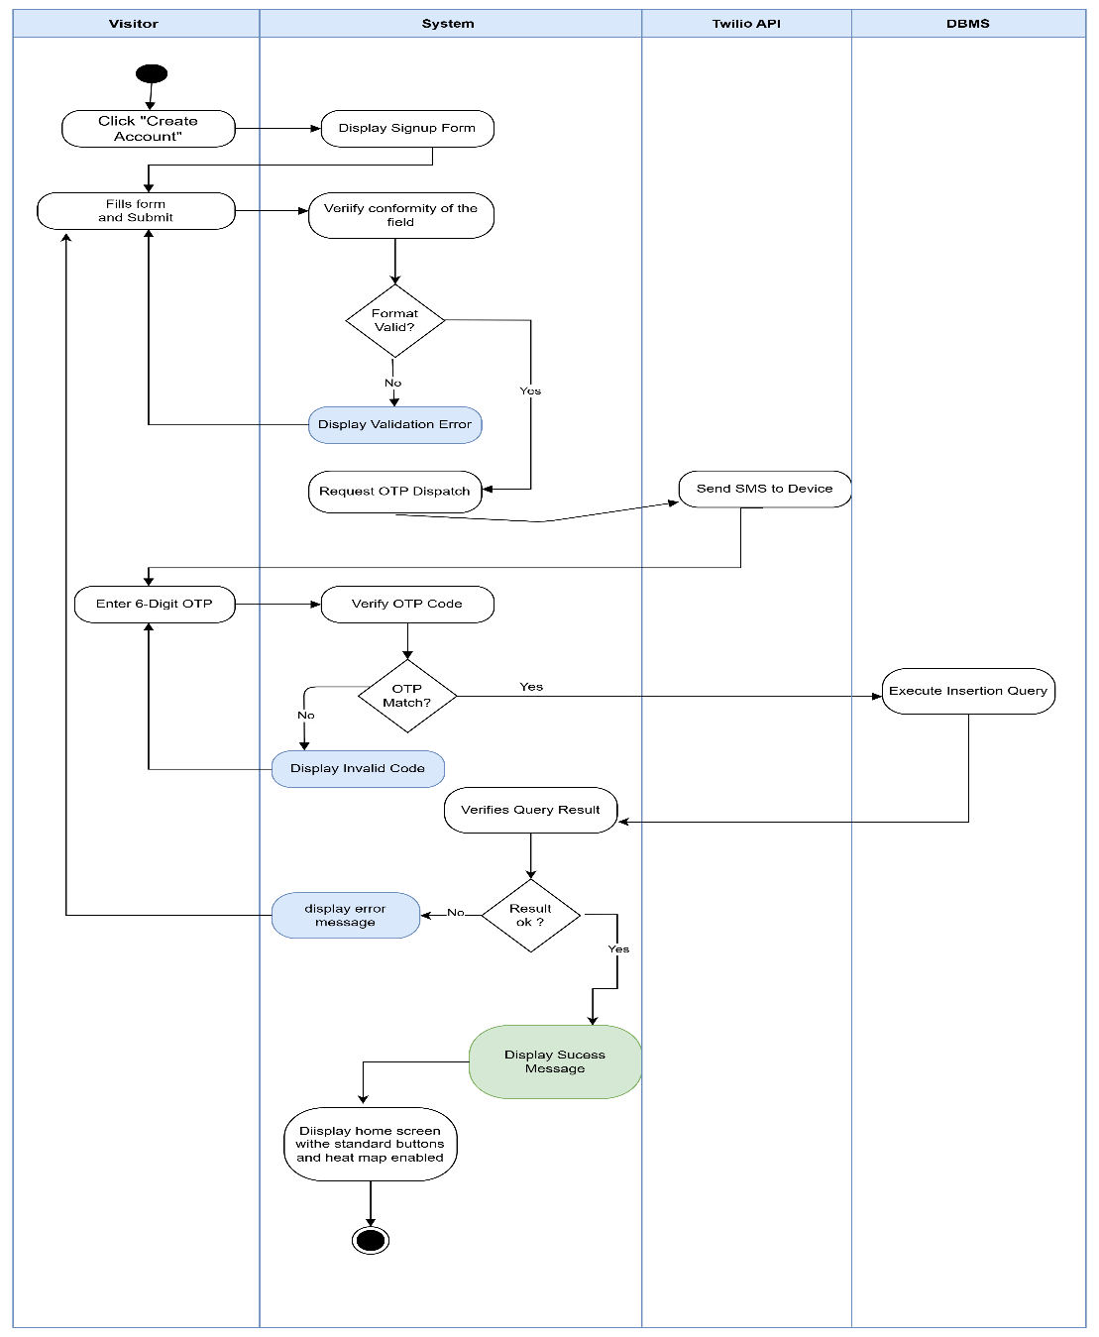
1. Activity Diagram: Create Account
Figure 19: Activity Diagram for Create Account

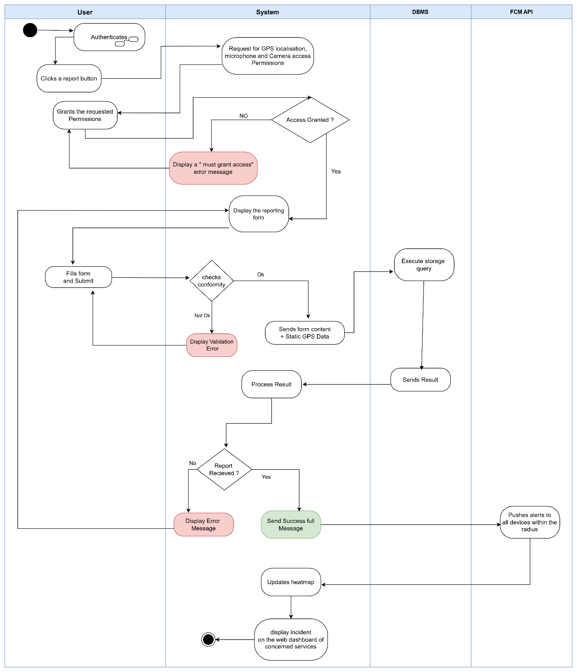
2. Activity Diagram: Standard Incident Reporting
Figure 20: Activity Diagram for Standard Incident Reporting

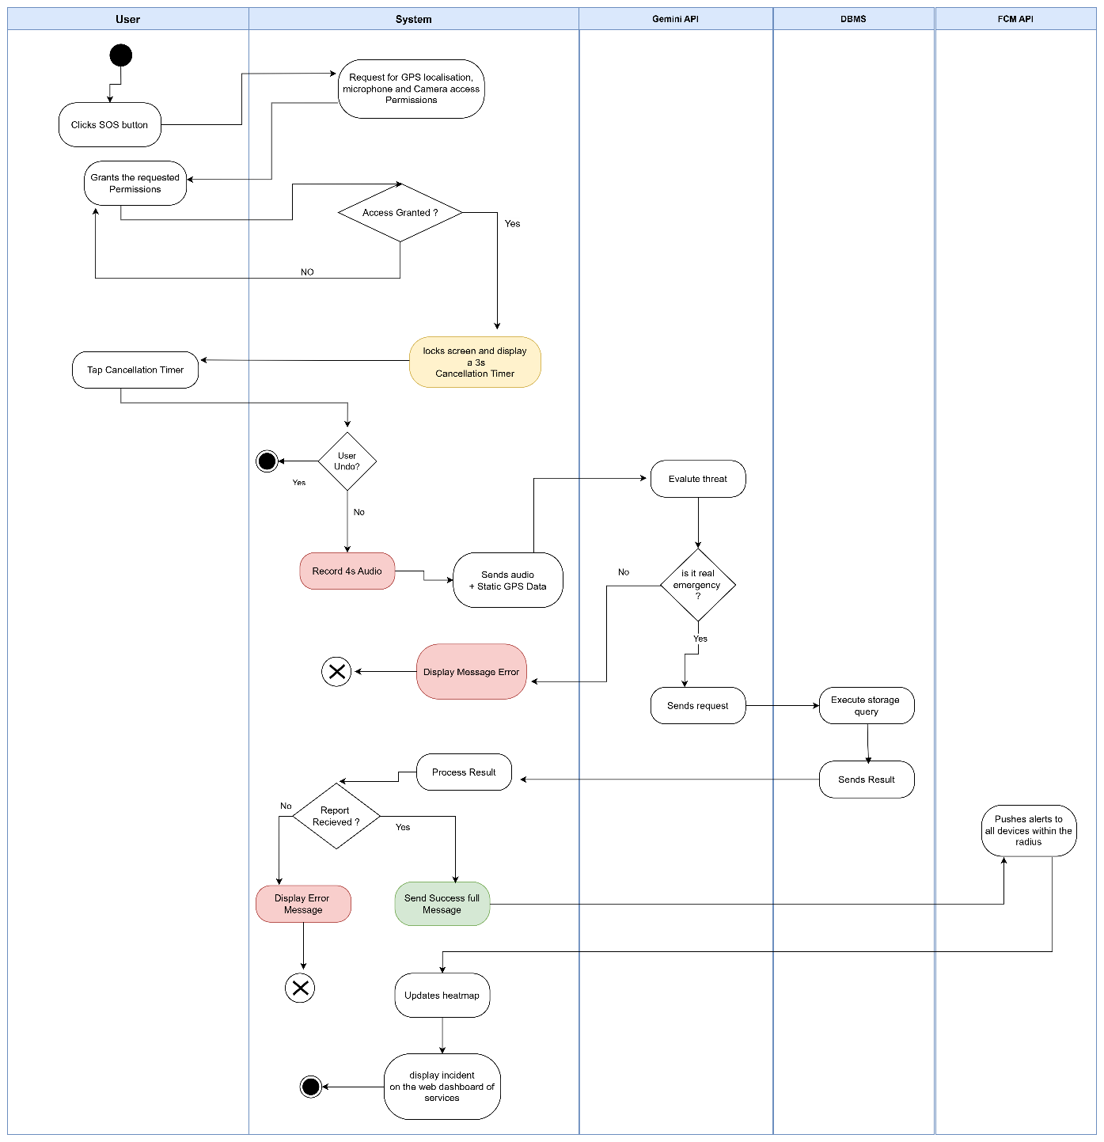
3. Activity Diagram: SOS Incident Reporting
Figure 21: Activity Diagram for SOS Incident Reporting

CONCLUSION
The analysis file allowed us to rigorously delimit the functional needs of the SOS Report application. By utilizing UML diagrams within the 2TUP framework, we have secured a detailed, chronologically and structurally accurate overview of the new system before moving into technical implementation.

FILE 4: CONCEPTION PHASE

Preamble

The conception phase will permit us to present in an orderly manner the components necessary for the good functioning of our software and also the architecture used for the proposed solution. It bridges the gap between the analysis phase and the realization phase
Content

INTRODUCTION

INTRODUCTION
I.

I.
CAPTURE OF TECHNICAL NEEDS

CAPTURE OF TECHNICAL NEEDS

A. PHYSICAL ARCHITECTURE

A. PHYSICAL ARCHITECTURE
B. LOGICAL ARCHITECTURE

B. LOGICAL ARCHITECTURE

II.

II.
RELATED UML DIAGRAMS

RELATED UML DIAGRAMS
A. CLASS DIAGRAM

A. CLASS DIAGRAM

B. STATE MACHINE DIAGRAM

B. STATE MACHINE DIAGRAM

CONCLUSION

CONCLUSION
C. PACKAGE DIAGRAM

INTRODUCTION
The conceptual phase will provide a detailed description of the necessary specifications, features, and operations required to meet the functional requirements of the proposed system, as outlined in the analysis phase. This stage aims to identify and consider essential components, both hardware and software as well as the system's structure (including network capabilities), processes, and procedures needed to achieve its objectives. We will examine several key diagrams, including the class diagram, state machine diagram, and package diagram, to support our understanding of the system's design and functionality

I. CAPTURE OF TECHNICAL NEEDS

A. Physical Architecture
When designing an application, it is important before going any further to know the architecture of this application. The choice of your architecture can be based on: the number of users, the data volume, transaction volume, performance requirements and security needs.
Within the scope of our project, we made use of the n-tier architecture This architecture separate it tiers from each other based upon the user and the manipulated data in the database. It is important to note that with the n-tier architecture, only neighbouring layers can communicate. Each layer has a well-defined communication interface and the evolution of the layer is independent of the other. The n-tier of our system is made up of:
- The API tier, which represents all the Secondary actors providing their services to SOSReport
- The client tier, which is also known as our presentation interphase.
- Application Tier, which represents our webserver.
- The data tier, which represents our DBMS server
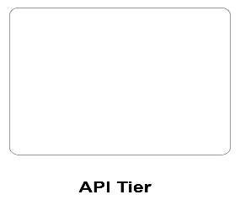

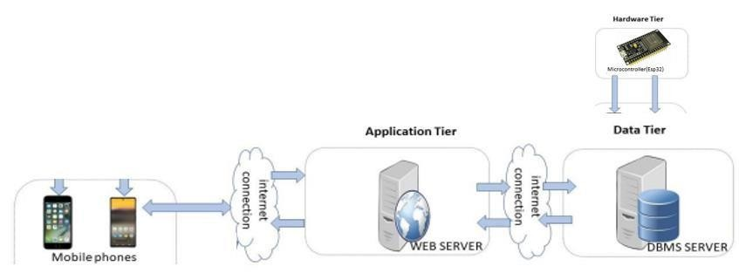
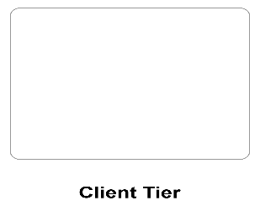
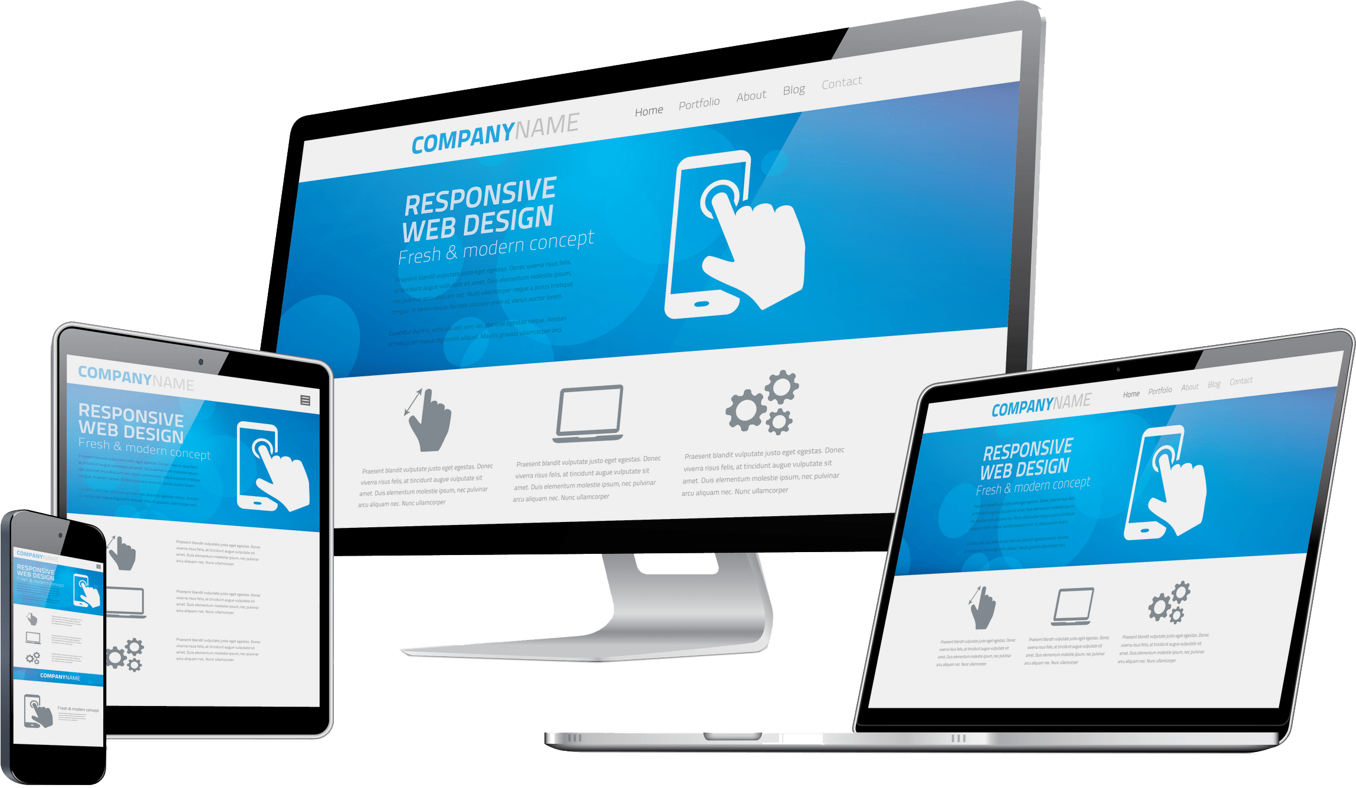
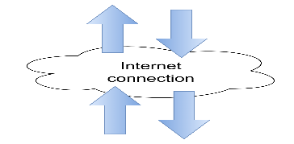

.
Figure 22: Physical architecture

B. Logical Architecture
Model View controller or MVC as it is popularly called, is a software design patten for developing application. A model view controller patten is made up of the following three parts.
- Model: The lowest level of the patten which is responsible for maintaining data.
- View: This is responsible for displaying all or a portion of data to the user.
- Controller: It handles software codes that controls the interactions between the model and the view.
MVC is popular as it isolates the application logic from the user interface and supports separation of concerns. Here the controller receives all requests for the application then works with the model to prepare data needed by the view. The view then uses the data prepared by the controller to produce a final response. The MVC can be represented as follows:
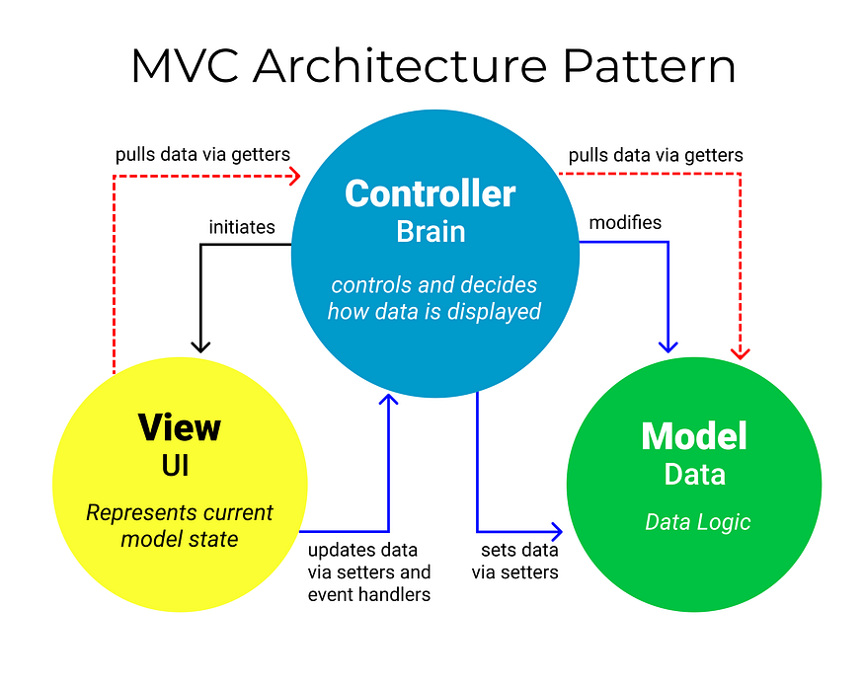

Figure 23: The MVC architecture (source: https://medium.com/@vinaygoyal0460/understanding-the-mvc-architecture-ff69898b80a3

II. RELATED UML DIAGRAMS

A. Class Diagram
1. Definition
A class diagram is a static diagram. It represents the static view of an application. class diagram is not only used for visualizing, describing and documenting different aspect of the system but also for constructing executable code of the software application. Class diagram describes the attribute and operation of a class and constraints imposed on the system. Its purpose is to model the static view of an application.

2. Formalism
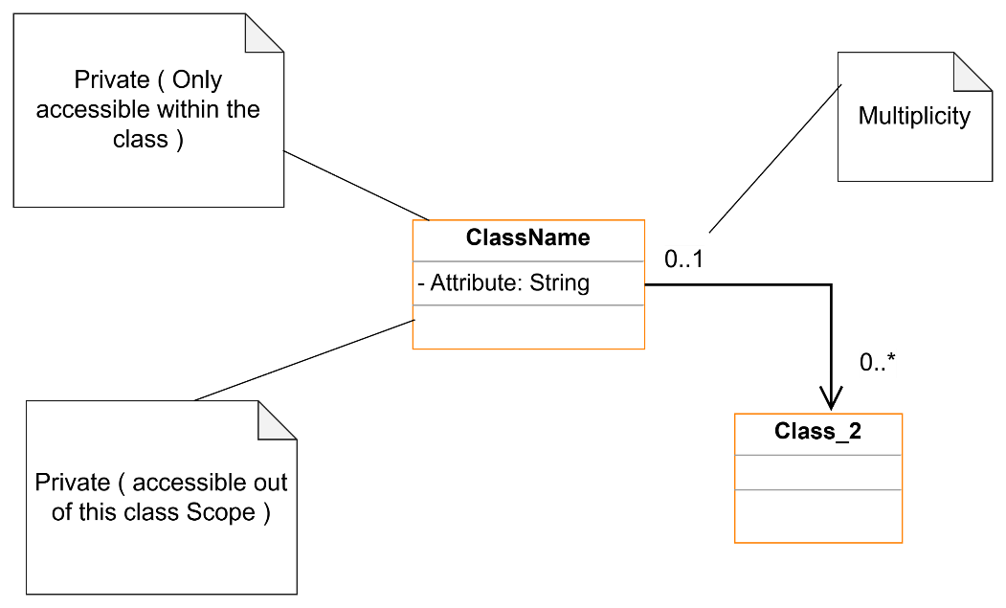
Figure 24: Formalism of the Class Diagram

3. Components of the Class Diagram

Table 25: Components of the Class diagram
Elements | Representation | Description
Class | 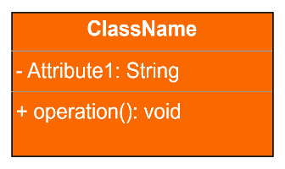 | Represents an entity within a system. It is an abstract representation or description of a set of objects in the application domain.
Generalization | 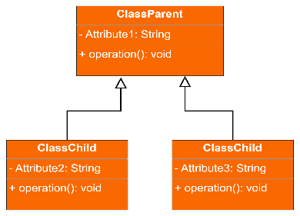 | it a relationship between a whole thing (called superclass) and a more specific thing (called subclass)
Composition | 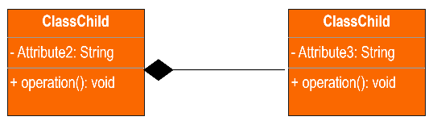 | If a parent of a composite is deleted, usually, all its parts are deleted with it.
Aggregation | 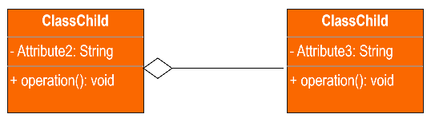 | If the parent of the aggregate is deleted, usually the children are not deleted.
Dependency | 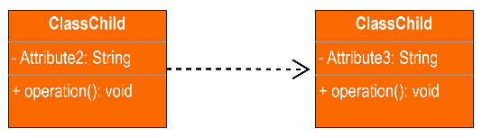 | It existed between two classes, if one changes it may cause the change in the order, but the other way around.
Association | 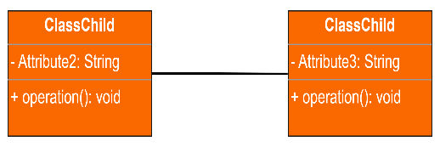 | It is a general type of relationship between elements, it may include cardinality, roles etc.

Class Diagram of SOS Report
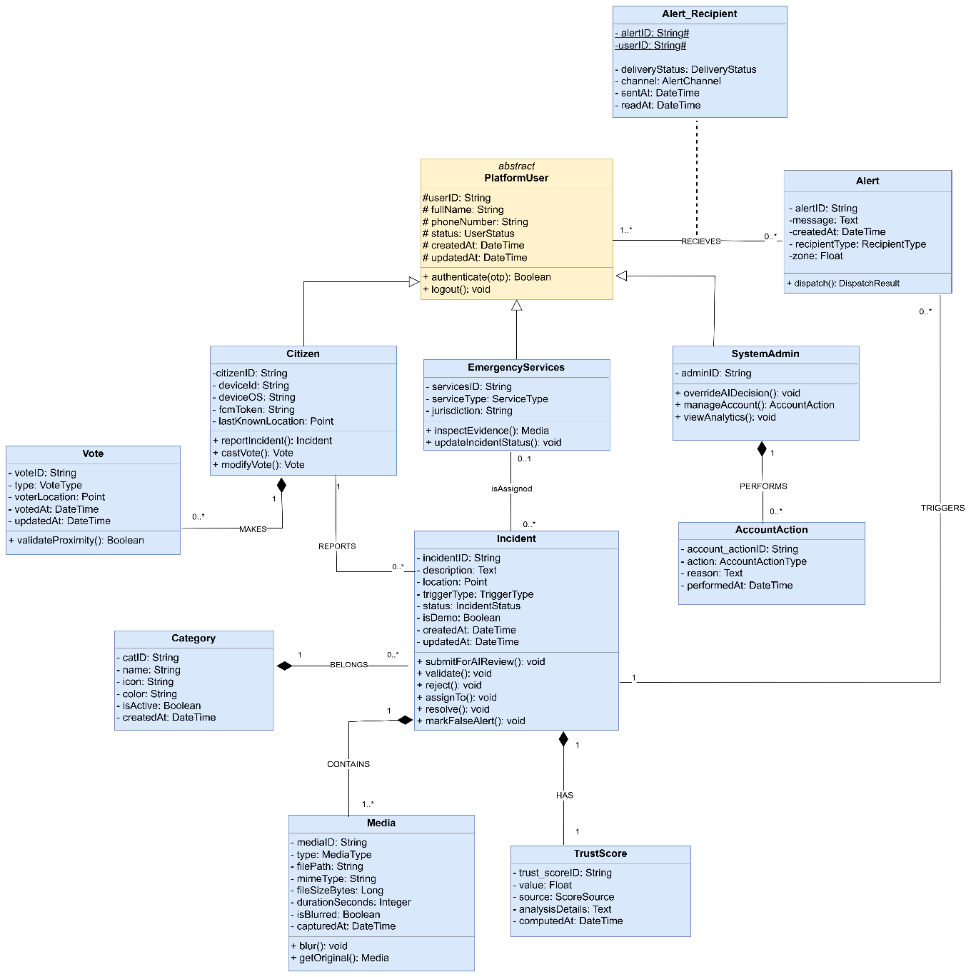
Figure 25: Class Diagram of SOS Report

B. State Machine Diagram
1. Definition
A state machine diagram describes the behavior of a single object in response to a series of events in a system. It models the dynamic flow of control from the state of a particular object within a system.
2. Formalism
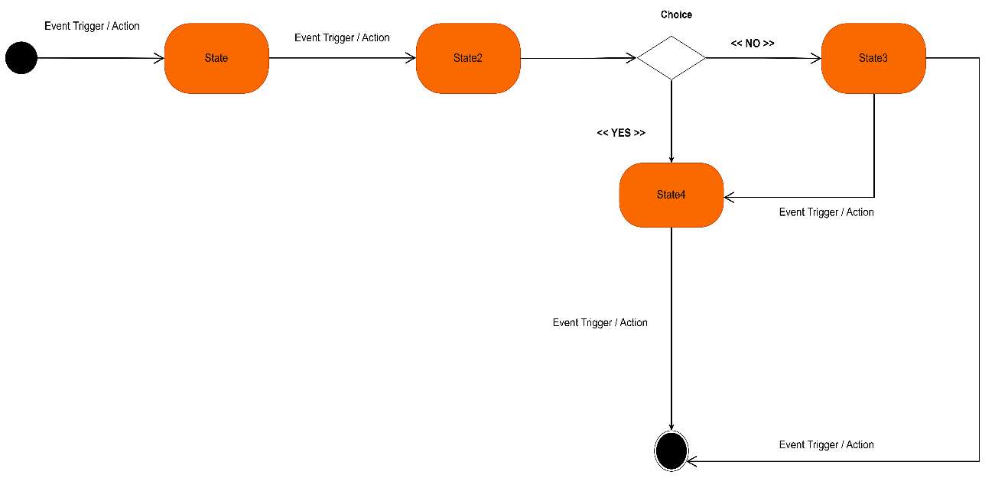
Figure 26: Formalism of the State Machine Diagram

3. Components of the State Machine Diagram
Table 26: Components of the State Machine diagram
Elements | Representation | Description
Initial State |  | It represents the initial or beginning of a system and it is represented by a block filled circle
Final State |  | It represents the final state or end of a system. It is represented by a filled circle within another circle
Transition | 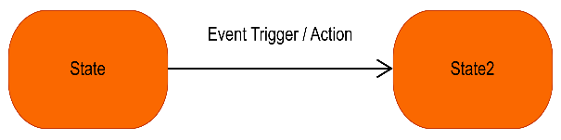 | it is a change of control from one state to another due to the occurrence of some events. It is represented by an arrow labelled with the event that causes it’s change of state.
State Box | 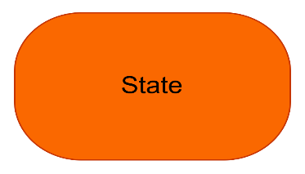 | It depicts the condition or circumstances of particular object of a class at a specific point of time.
Decision Point |  | A diamond symbol that indicates a dynamic condition with branched potential results
Exit Point |  | Implies that the execution of a state by means of it context is terminated

State machine diagram of SOS Report
State Machine: The Incident Lifecycle
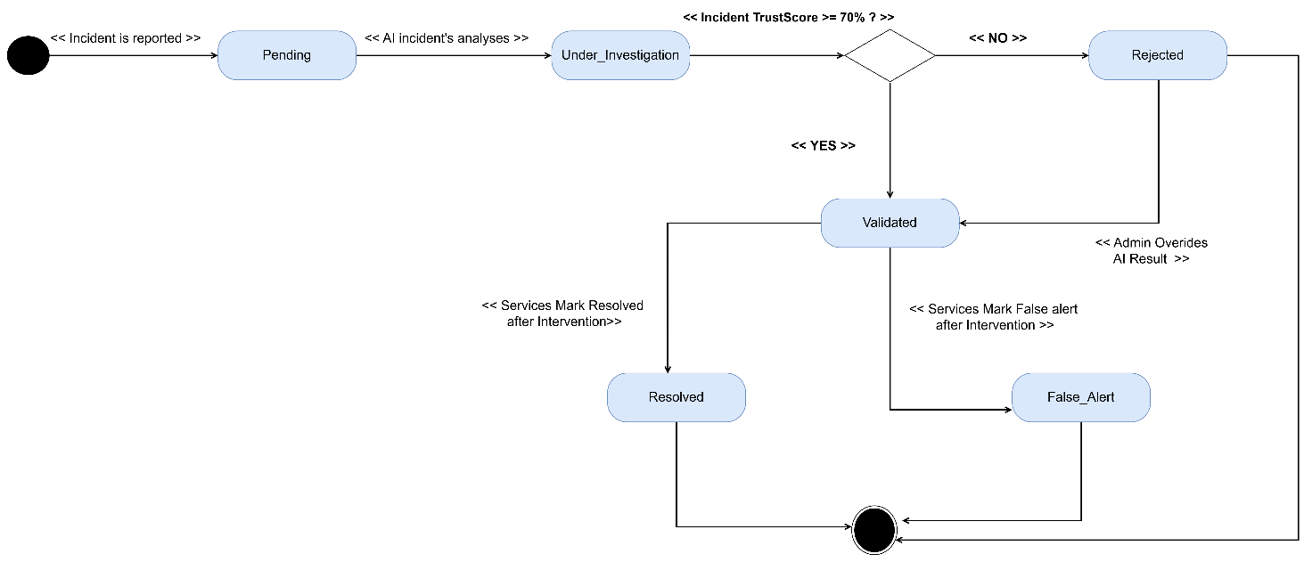
Figure 27: State Machine Diagram for Incident Lifecycle
State Machine: The Account Lifecycle
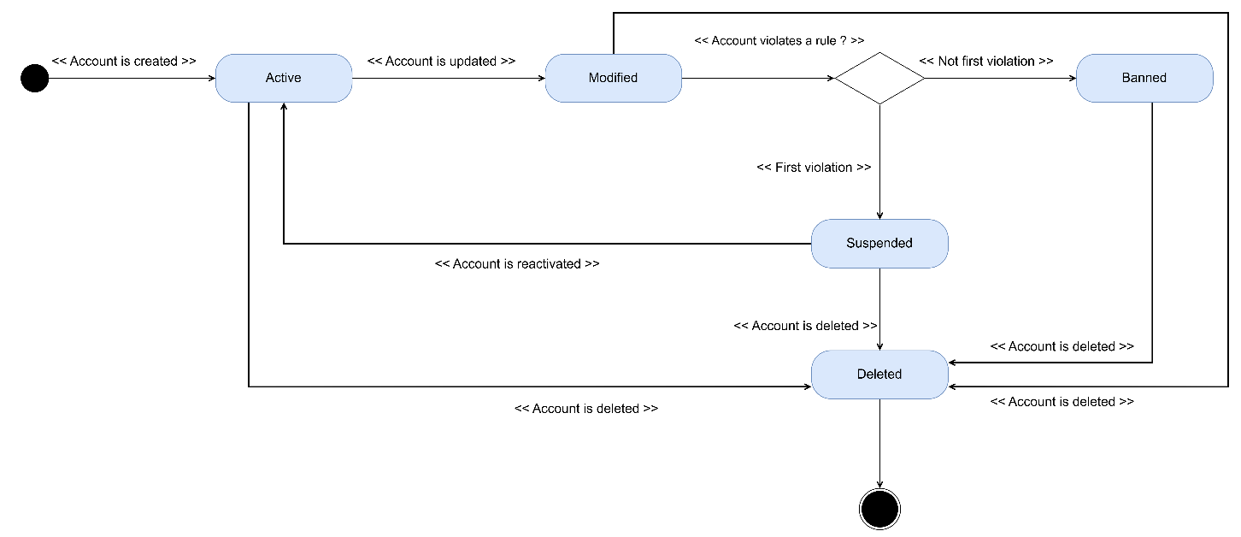
Figure 28: State Machine Diagram for an Account Lifecycle

C. Package Diagram
1. DEFNITION
They are structural diagrams used to show the organization and arrangement of various model elements in the form of a package. A package diagram is group of related UML elements such as diagrams, documents, classes, or even other packages. Package diagrams are commonly used to provide a visual organization of the architectural layout within any UML classifier such as software systems.

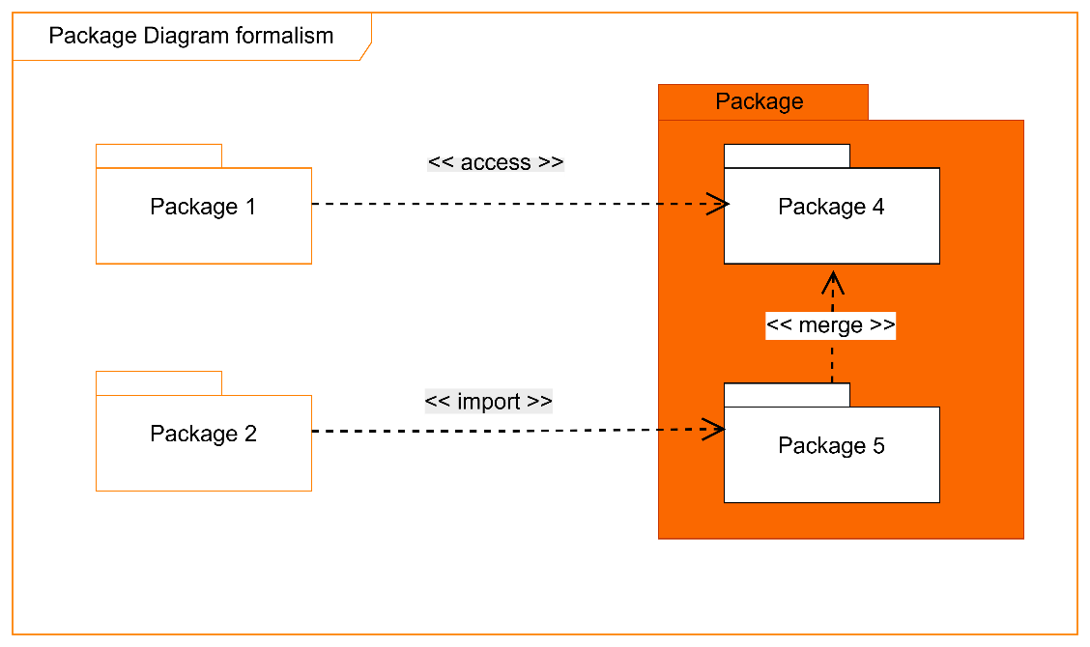
2. Formalism
Figure 29: Formalism of the Package Diagram

3. Components of the Package Diagram
Table 27: Components of the Package diagram
Elements | Representation | Description
Package | 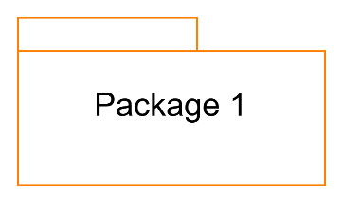 | It is namespace used to group together logically related elements within a system. Each element contains within the package should be a packageable element and have a unique name
Package import | 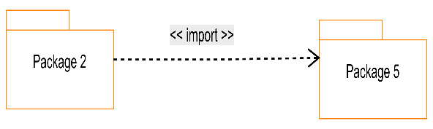 | A relationship Indicate that, functionality has been imported from one package to another.
Package access | 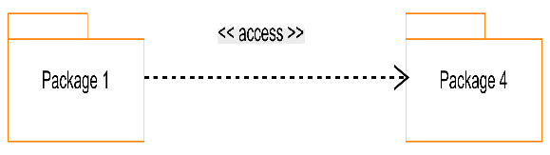 | A relationship Indicates that one package requires assistance from the function of another package.
Package merge | 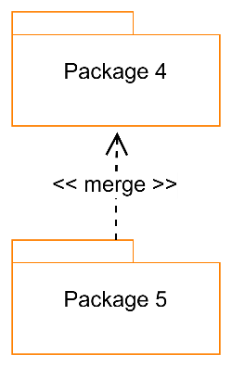 | It is a relationship which shows that, the functionality of two packages are combines to a single function.

Package Diagram of SOS Report
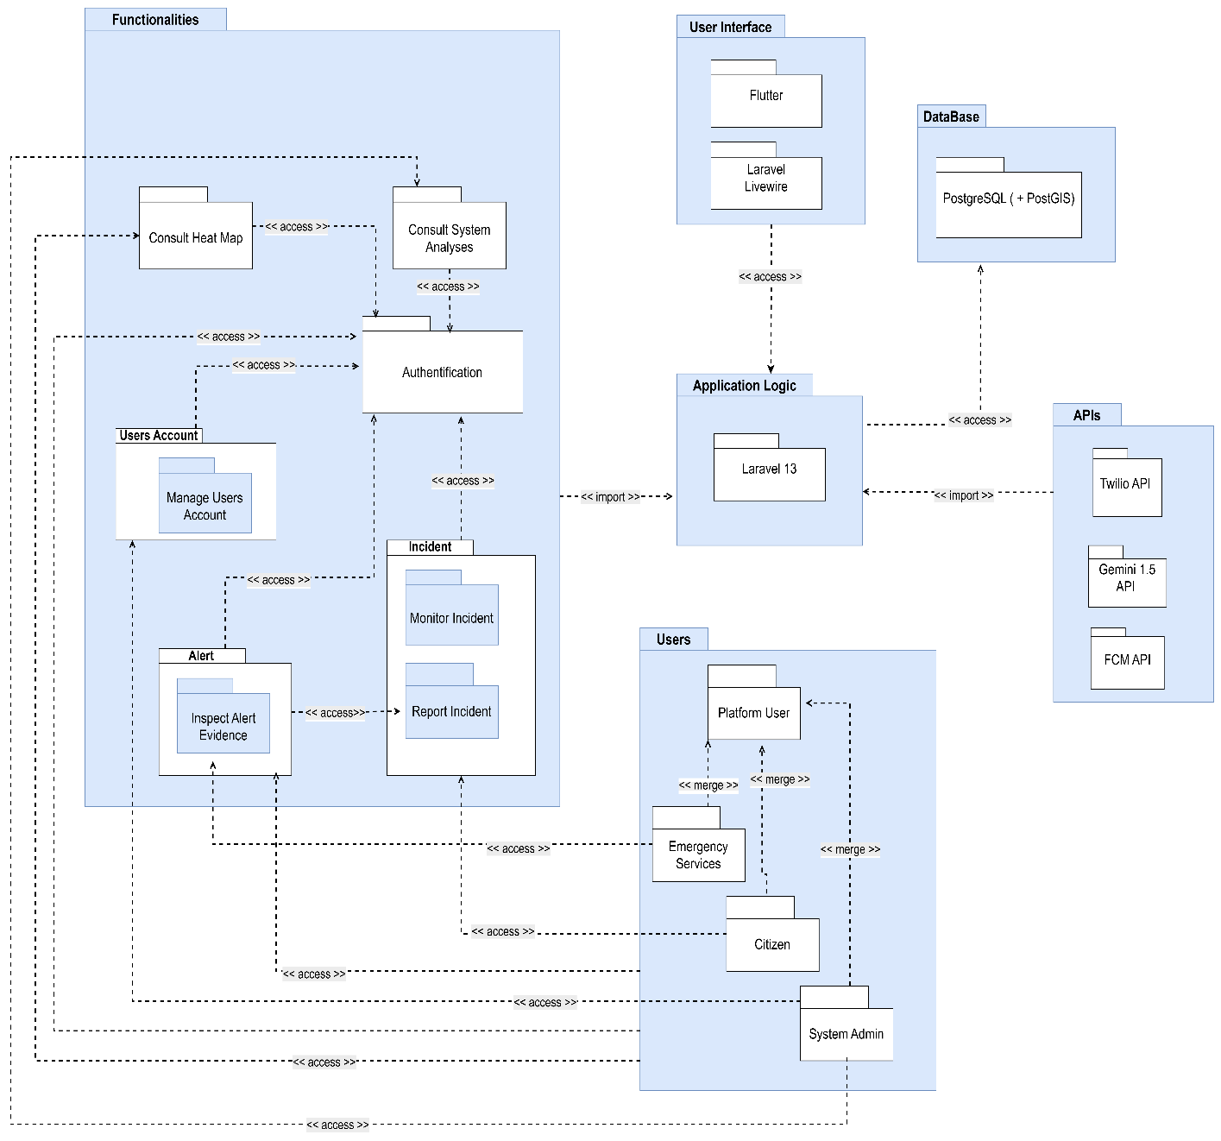
Figure 30: Package Diagram of SOS Report

CONCLUSION
The conception phase allowed us to bring out the data necessary for the creation of our database and the implementation of our application. The different elements modeled in this part allowed us to have a global view of the different modules of our application; therefore, the next step of our project will be the drafting of the realization file taking into account the different elements modeled above

FILE 5: REALIZATION PHASE

Preamble

In this phase we will go straight forward in the implementation of our solution, we will base ourselves on the analysis and conception phases and also present the component and deployment diagrams.
Content

INTRODUCTION

INTRODUCTION
I.

I.
RELATED UML DIAGRAMS

RELATED UML DIAGRAMS

II.

II.
TECHNOLOGICAL CHOICES

TECHNOLOGICAL CHOICES

A. DEPLOYMENT DIAGRAM

A. DEPLOYMENT DIAGRAM

B. COMPONENT DIAGRAM

B. COMPONENT DIAGRAM

CONCLUSION

CONCLUSION

INTRODUCTION
Design and modeling are important links in the development process of an application because they make it possible to define and specify the different elements constituting the application or system studied. Realization is the culmination of the work carried out upstream because it makes it possible to physically create the various objects that were designed, and to bring the computer system to life. Throughout this phase, we will present the software, physical, and hardware architecture of our system, through diagrams such as the component diagram and deployment diagram.

I. RELATED UML DIAGRAMS

A. Deployment Diagram
1. Definition
Deployment diagram is a structural diagram used to visualize the topology of the physical components of a system, where the software is deployed. They consist of nodes and their relationship. It is related to the component diagram because the components are deployed using the deployment diagram. A deployment diagram consists of nodes. Nodes are nothing but physical hardware used to deploy the application.
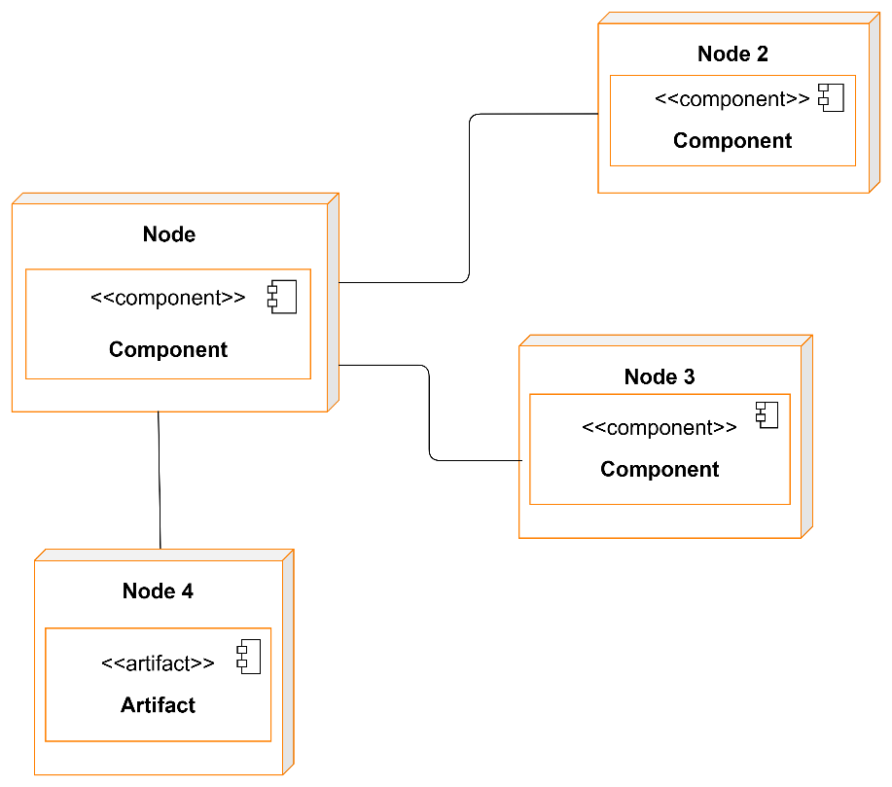
2. Formalism
Figure 31: Formalism of the Deployment Diagram

3. Components of the Deployment Diagram
Table 28: Components of the Deployment diagram
Elements | Representation | Description
Component | 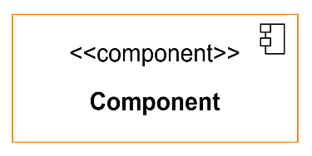 | A component represents a software entity of the system.
Node | 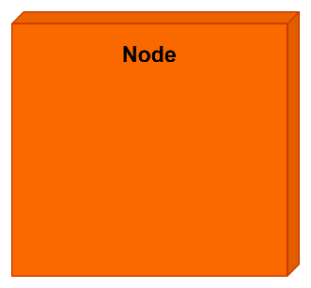 | A node represents a set of hardware elements of the system. A three-dimensional cube represents this entity or node.
Artifact | 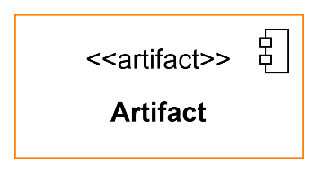 | An artifact is a major product, which is produced or used during the development of a software. E.g diagrams, data models, setup scripts
Association |  | An association helps to connect two nodes together which permits them to communicate together

Deployment Diagram of SOS Report
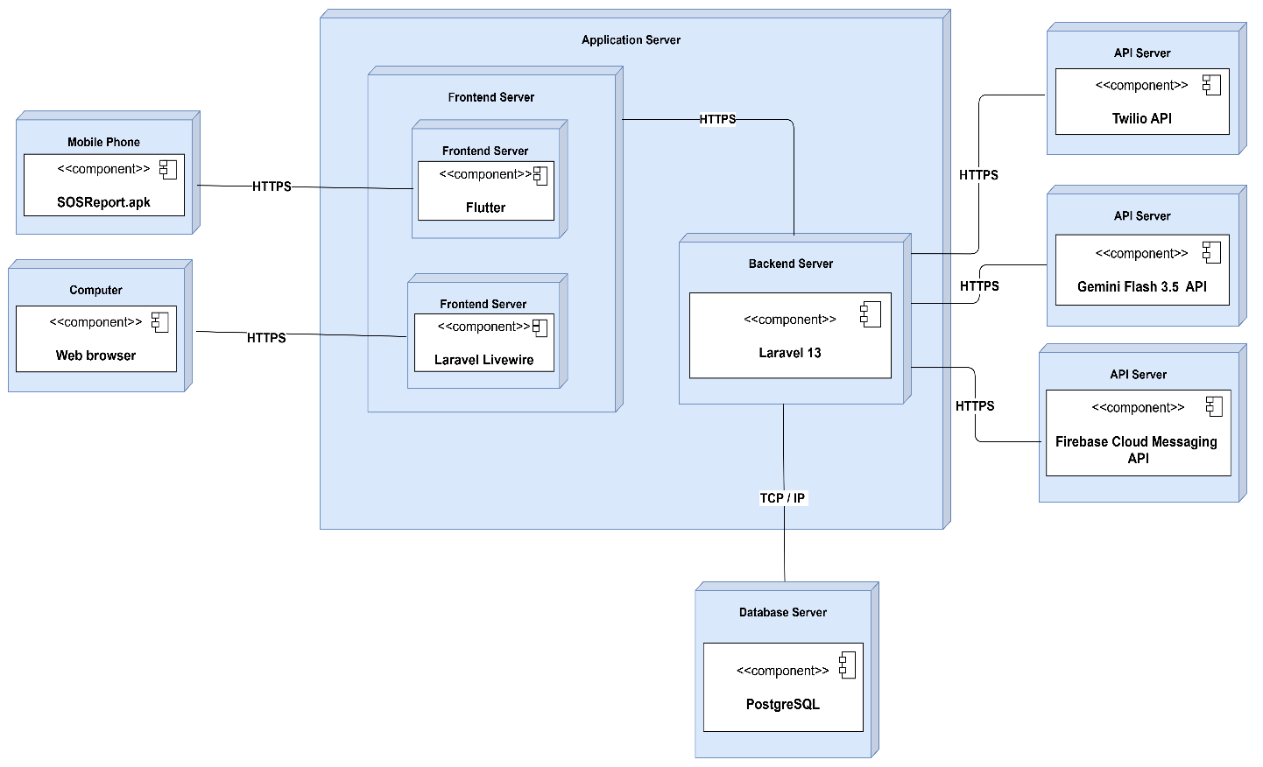
Figure 32: Deployment Diagram of SOS Report

B. Component Diagram
1. Definition
Component diagrams are used to model the physical aspect of a system. By physical aspect we mean elements such as Executables, libraries, files, document etc. which resides in a node. The component diagram does not describe the functionality of the system, but it describes the components used to make those functionalities.
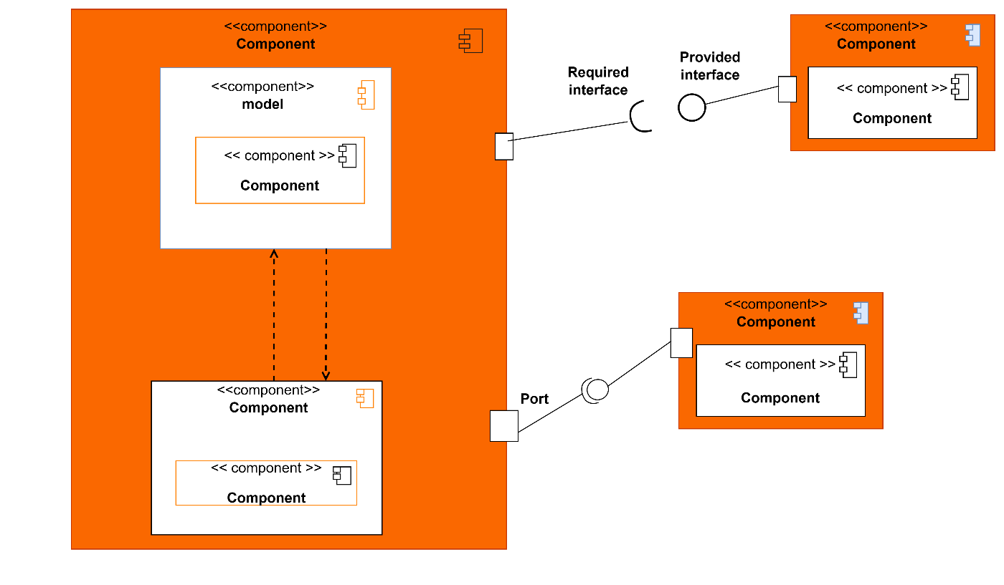
2. Formalism
Figure 33: Formalism of the Component Diagram

3. Components of the Component Diagram
Table 29: Components of the Component diagram
Elements | Representation | Description
Component | 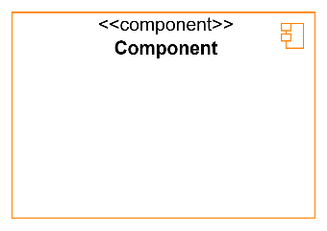 | Represents the modular part of the system that encapsulates its content. In other words, it is part of a system or application.
Port | 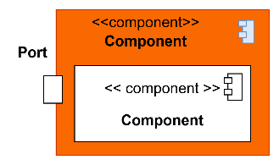 | Specifies a distinct interaction point between that classifier element and its environment
Required Interface | 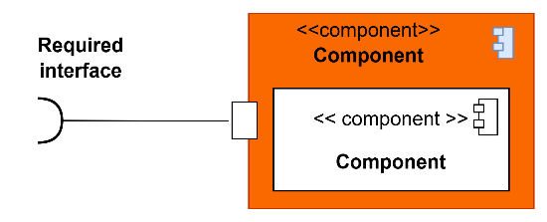 | It is a straight line from the component box with an attached half circle representing interfaces where a component requires information in order to perform its own functions.
Provided Interface | 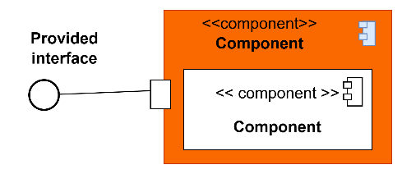 | It is a straight line from the component box with an attached circle representing interfaces where a component produces information used by required interfaces
Dependency | 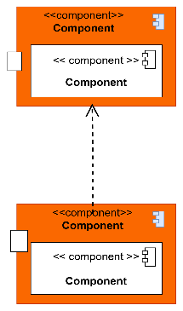 | Dependency is a directed relationship which is used to show that some components are dependent on others for their correct functioning.

Component Diagram of SOS Report

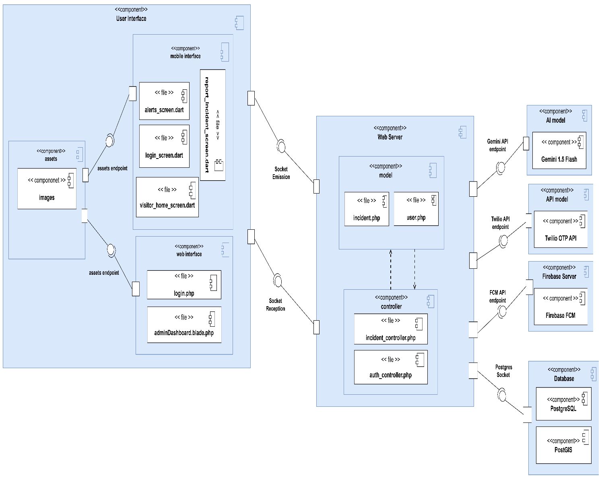
Figure 34: Component Diagram of SOS Report

II. TECHNOLOGICAL CHOICES
Table 30: Tools used to develop SOS Report
Software | Role | Reason for use | Image
OS WINDOWS 11 | The operating system required to run the software is the one on which we have worked. | Windows 11 has a user-friendly interface that is familiar to many users, making it easy to navigate and use. | 
Visual Paradigm | The software engineering workshop used for solution modelling. We utilized this tool for modelling the various diagrams of our system | . Supports multiple modelling languages and methodologies, making it suitable for various project requirements and enabling teams to adapt to different development processes. | 
Framework Laravel | The PHP framework used to build the backend/server-side logic and REST API of the platform. | Provides a robust MVC architecture, built-in security features (authentication, CSRF protection), an expressive ORM (Eloquent) for database management, and a large ecosystem that speeds up backend development. | 
Visual Studio code | Visual Studio Code is a lightweight, open-source code editor developed by Microsoft, supporting multiple programming languages. Using for writing of application code. | . Combines tools for version control, debugging, and terminal access in one interface, improving efficiency and reducing the need for multiple applications. | 
Github | It is a website and cloud service that helps developers store and manage their code. | Git allows developers to track changes, revert to previous versions, and maintain a history of modifications, ensuring that no work is lost and enabling easy recovery. | 
Framework Flutter | The cross-platform UI framework used to develop the mobile application (Android and iOS) from a single codebase. | Enables faster development with a single Dart codebase for both platforms, offers a rich set of customizable widgets, and provides near-native performance, reducing the resources needed to maintain separate Android and iOS versions. | 
Node.js | Node.js is an open-source and cross-platform JavaScript runtime environment. It is a popular tool for almost any kind of project! | It is used to build our backend, helping us to have a dynamic web application | 
PostgreSQL | PostgreSQL is a popular open-source relational database management system | It is used to store and manage our data | 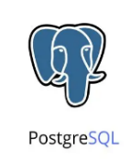
MS PowerPoint | MS PowerPoint is a presentation software that allows users to create dynamic slideshows comprising text, images, videos, and animations. Able us to create slideshow presentations for application | Its intuitive interface and templates make it easy for users to create professional presentations quickly, regardless of their technical skill level. | 
MS Word | MS Word is a widely used word processing application that allows users to create, edit, and format text documents. Using in-application report creation. | Offers extensive options for formatting text, images, and layouts, enabling the creation of professional quality documents. | 
GanttProject | GanttProject is a free, open-source project management tool that allows users to create Gantt charts for planning and scheduling projects | Allows users to assign tasks, set deadlines, and manage resources effectively, facilitating better project coordination and efficiency. | 
Postman | The API testing and documentation tool used to test the Laravel backend endpoints during development. | Allows quick creation, testing, and debugging of API requests without needing a frontend, and supports organizing requests into collections for consistent, repeatable testing across the team. | 
Android Studio | The integrated development environment (IDE) used for building, debugging, and testing the Android version of the application. | Offers native Android emulators, a built-in Flutter/Dart plugin, and direct access to Android SDK tools, making it easier to debug platform-specific issues and configure native permissions | 
Firebase Cloud Messaging (FCM) | The push notification service used to deliver real-time alerts (new incidents, status updates) to users' mobile devices. | Free and tightly integrated with Flutter/Android, supports both foreground and background delivery, and scales to a large number of devices without added infrastructure cost | 

CONCLUSION
In conclusion, the realization phase represents a pivotal stage in the development of the SOS Report system, where our design and planning come to fruition through the implementation of the chosen technology stack and the creation of essential UML diagrams. By utilizing modern technologies such as Flutter for the frontend, Laravel for the backend and other supporting tools, we build a scalable, efficient, and user-centric application. The deployment and component diagrams developed during this phase provide a clear understanding of the system architecture, promoting effective communication within the development team and ensuring alignment with project objectives. With this solid foundation, we are well-prepared to move forward into the functional testing phase, where rigorous evaluation will confirm that all features perform as expected.

FILE 6: TEST OF FUNCTIONAITIES

Preamble

This phase aims at testing the software or application to verify if the system is working as expected. It involves testing individual functionalities and capabilities of the software to ensure that they work correctly and meet the specified needs
Content

INTRODUCTION

INTRODUCTION
I. APPLICATION FUNCTIONALITIES

I. APPLICATION FUNCTIONALITIES

II. TEST SHOWCASES

II. TEST SHOWCASES

CONCLUSION

CONCLUSION

INTRODUCTION
This phase is the systematic process that involves evaluating the functionality of a software application or system in different phases or stages of its development lifecycle. This testing approach ensures that each phase of the software development process is thoroughly tested for its intended functionalities and overall performance. Its main goal is to identify and rectify any defects, and bugs during the process.

I. APPLICATION FUNCTIONALITIES
- User Registration and Authentication
Enables the creation of eligible user account and also permits secure access for citizens, emergency services, and administrators via Twilio OTP Authentication.
- Reporting Incident
Standard Reporting
Allows citizens to report incidents (e.g., road accident, domestic fire cash) with mandatory details like audio recording, description, video and photos, validated for format and size, using the standard Report Incident cards.
SOS Reporting
Permits citizens encountering emergency situations to perform a quick reporting (via one-click on the SOS button) directly to the police service, and receive a quicker response.
- Consult Alert Evidences
Permits the administrator and the Emergency service dispatcher to view details of an incident such as the geographical coordinates, the audio/video/photo provided and the description, once the Gemini AI has finished to analyzed and confirms its veracity.
- Confirm Arrival
Allows emergency services to confirm they received the reporting and they are on their way, thereby providing a tracking of their position towards the location of the incident.
- User Accounts Management
The administrator has the possibility to modify, delete, suspend or ban accounts of users that are breaking the rules of the system or the laws.

- Monitor Incident
This functionality enables the citizen to confirm whether an incident reported by a neighbor is true, or contest if it is not the case
- Override AI Result
This enables the Administrator to help the Gemini AI to learn from its errors by overriding the AI’s result about an incident when it was false, thereby helping the AI to perform more accurate analysis in future.

II. TEST SHOWCASES
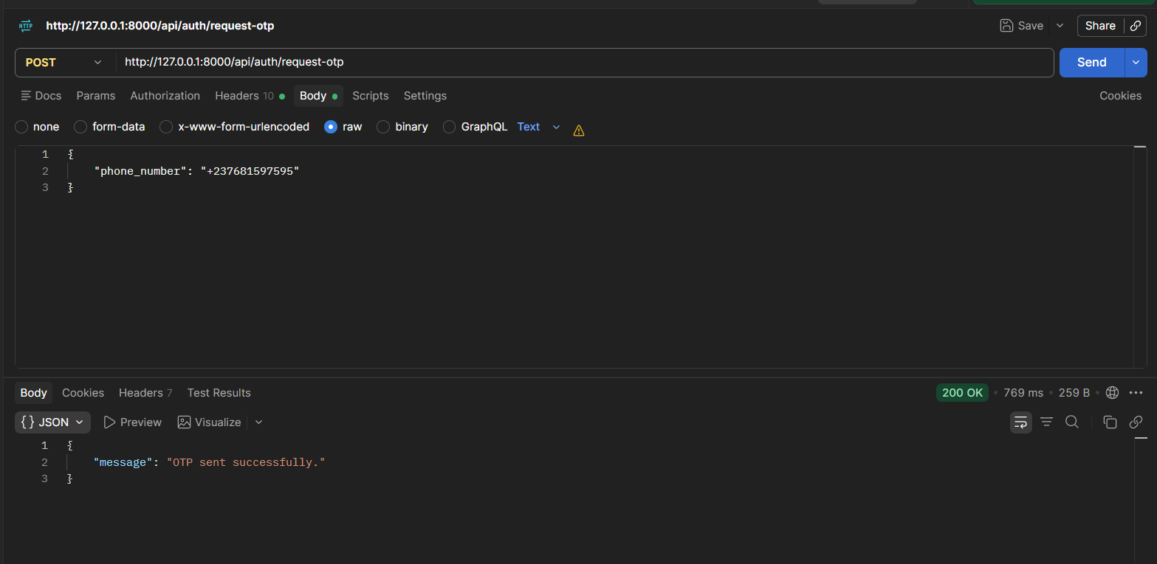
Step 1: Request OTP code
Figure 35: Testing Request for OTP code

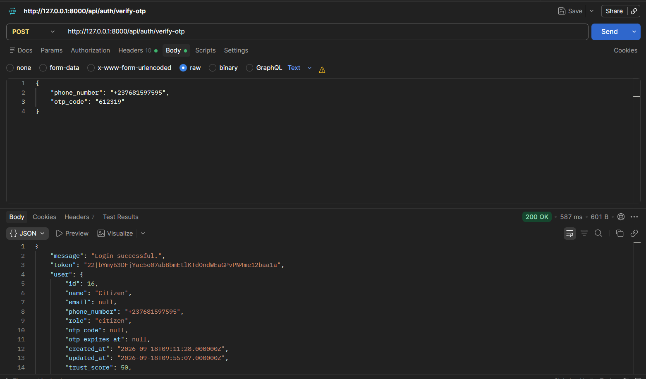
Verify OTP & Retrieve Sanctum Token
Figure 36: Testing OTP Verification

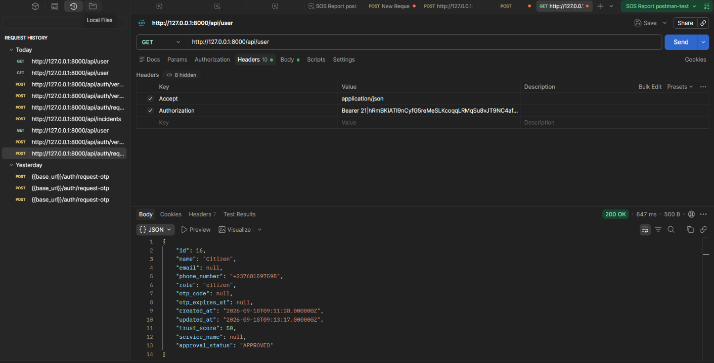
Test Protected Route (Check Citizen Profile)
Figure 37: Testing for Check of Citizen Profile
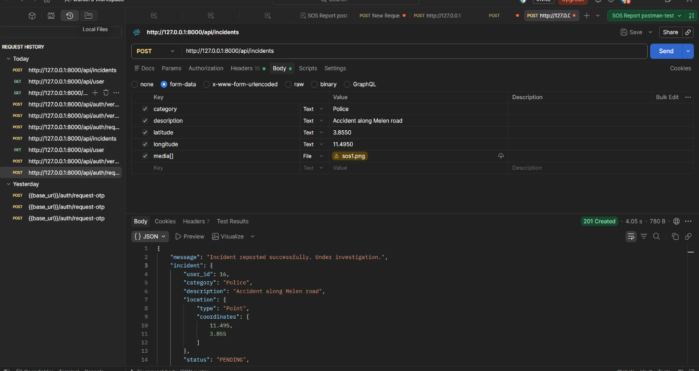
Report Incident / SOS with Media Evidence
Figure 38: Testing for Report Incident
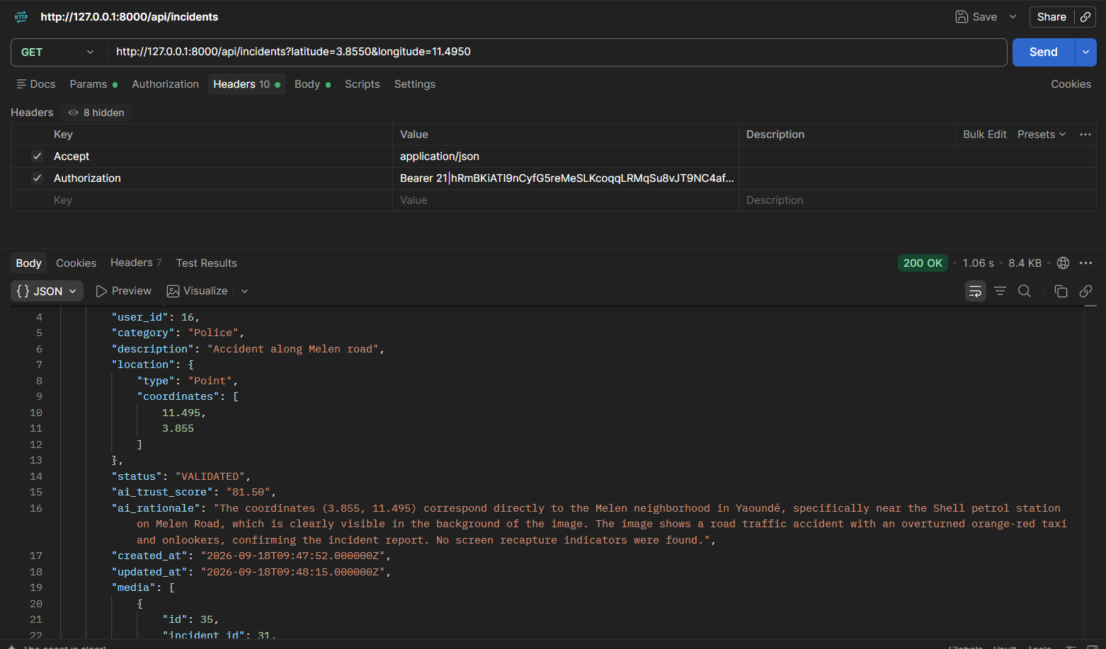
Query Nearby Incidents (PostGIS Radar Test)
Figure 39: Testing forQuerying Nearby Incidents
Cast a Geofenced Community Vote
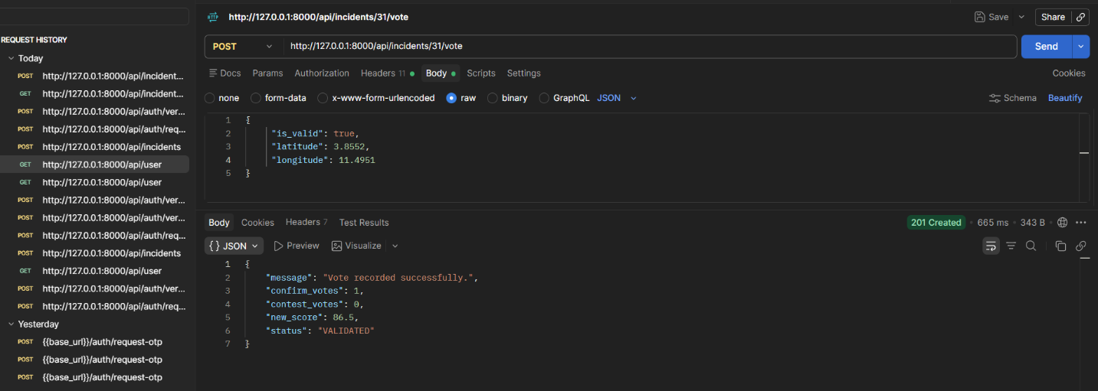
Test Case A: Citizen is WITHIN 1 km (< 1000 m)
Figure 40: Testing Community vote when found in the predefined Area

Test Case B: Citizen is OUTSIDE 1 km (Geofence Rejection) Change coordinates to 3.9000, 11.5200 (> 5 km away):
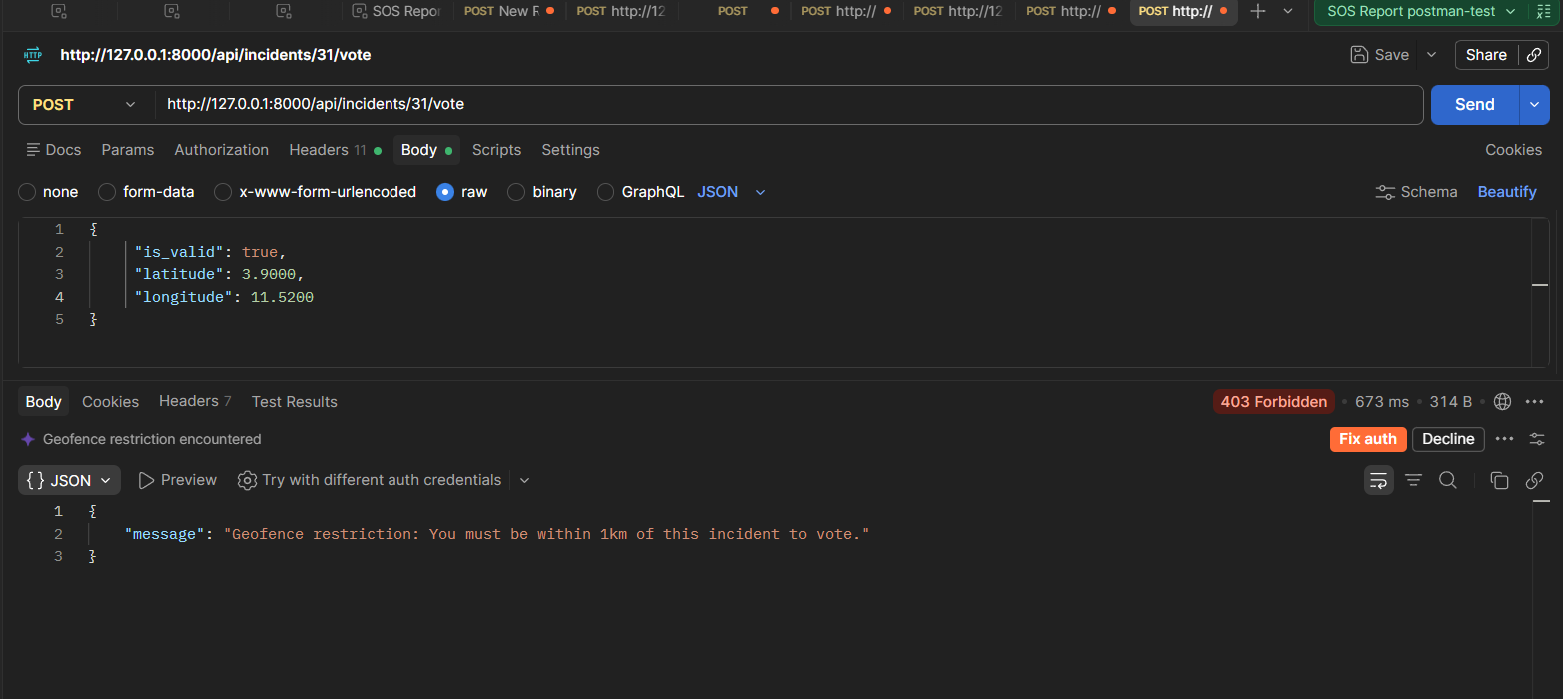
Figure 41: Testing Community vote when found Out of the predefined Area

CONCLUSION
Testing is an integral part of the software development life cycle and is performed to verify the correctness, reliability, and robustness of the implemented functionality. The functionality testing phase is therefore a critical stage in software development where the implemented features are validated, and any issues are identified and resolved.

FILE 7: INSTALLATION GUIDE AND USER GUIDE

Preamble

A user guide explains how to use a software application in a language that a non- technical person can understand. Thus, it enables the user to easily use the application to familiarize themselves with the software and discover all its functionalities.
Content

INTRODUCTION

INTRODUCTION
I. INSTALLATION OF THE APPLICATION

I. INSTALLATION OF THE APPLICATION

II. USER GUIDE

II. USER GUIDE

CONCLUSION

PERSPECTIVESCONCLUSION

INTRODUCTION
The user manual is the document established after the realization of an application, software or platform. It informs on the question "how to use the software, the application or the platform that you have in front of you? ". It is therefore crucial for us to offer the various users of our platform a guide allowing them to easily perform various operations on our platform.

I. Installation of The Application
Hardware and System Prerequisites
- Mobile Device: Minimum Android 8.0 or iOS 12. Active GPS sensor and internet connection (3G/4G).
- Permissions: The user must explicitly grant Location, Camera, and Microphone permissions upon the first launch.
- Server OS: Ubuntu 22.04 LTS (x86_64) or Windows Server with WSL2.
- Runtime Dependencies: PHP 8.3 with extensions (php-pgsql, php-gd, php-curl, php-mbstring, php-xml), Node.js v20+, Composer 2.x.
Installation Steps for final Android product:
- Download the SOS Report APK.
- Open device settings and allow installation from "Unknown Sources."
- Install the application and launch it. Accept the mandatory legal disclaimer regarding false alerts.
Installation Steps for Live Presentation Multi-Terminal Setup
Table 31: Installation Steps for Live Presentation
Terminal | Working Directory | Command Line Execution | Operational Purpose
Terminal 1: Web & API Server | sos_report_backend | php artisan serve --host=0.0.0.0 --port=8000 | Hosts REST API, Livewire Web UI, and static media endpoints.
Terminal 2: Asynchronous Queue Worker | sos_report_backend | php artisan queue:work --tries=3 | Dequeues background triage jobs with FOR UPDATE SKIP LOCKED.
Terminal 3: Vite Asset Bundler | sos_report_backend | npm run dev | Compiles Tailwind CSS and Alpine.js assets with Hot-Module-Reloading.
Terminal 4: Flutter Mobile App | Level2_Defence_Project | flutter run -d <device_id> | Compiles and launches native APK on test smartphone with sensor bindings.

Installation Steps: Spatial Indexing and PostGIS Setup Command
# Inside PostgreSQL console :
psql -U postgres -d sos_report_db
# Ensure PostGIS extension is active
CREATE EXTENSION IF NOT EXISTS postgis;
# Verify or create GiST spatial index on incidents location column
CREATE INDEX IF NOT EXISTS incidents_location_spatialindex ON public.incidents USING gist (location);

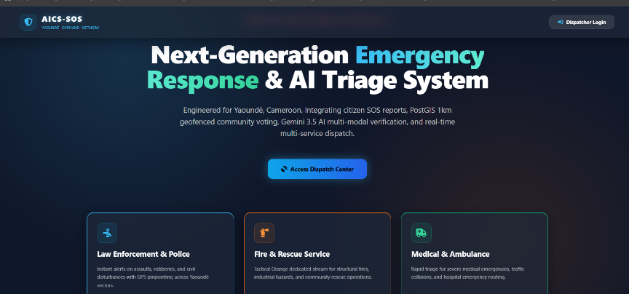
II. User Guide
Figure 42: Landing page of the Web application
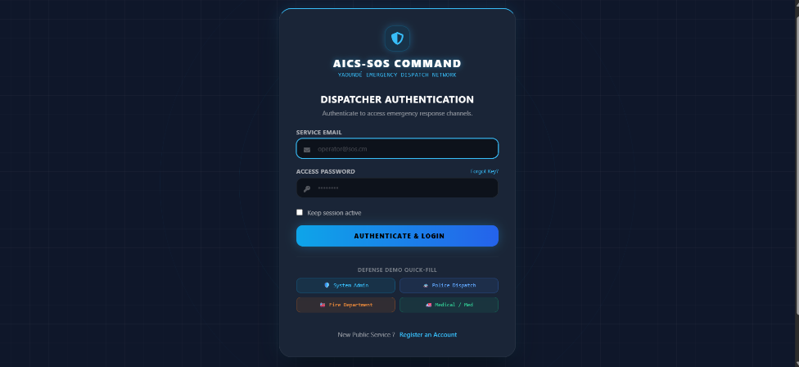
Figure 43: Login page of the Web application

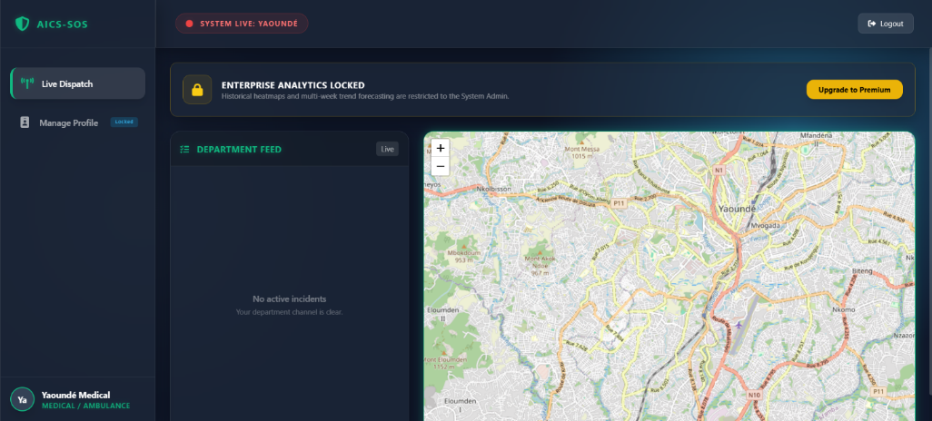
Figure 44: Dashboard of the Medical Emergency Service
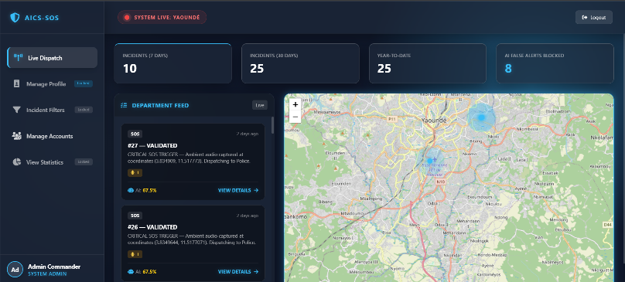
Figure 45: Dashboard of the System Administrator
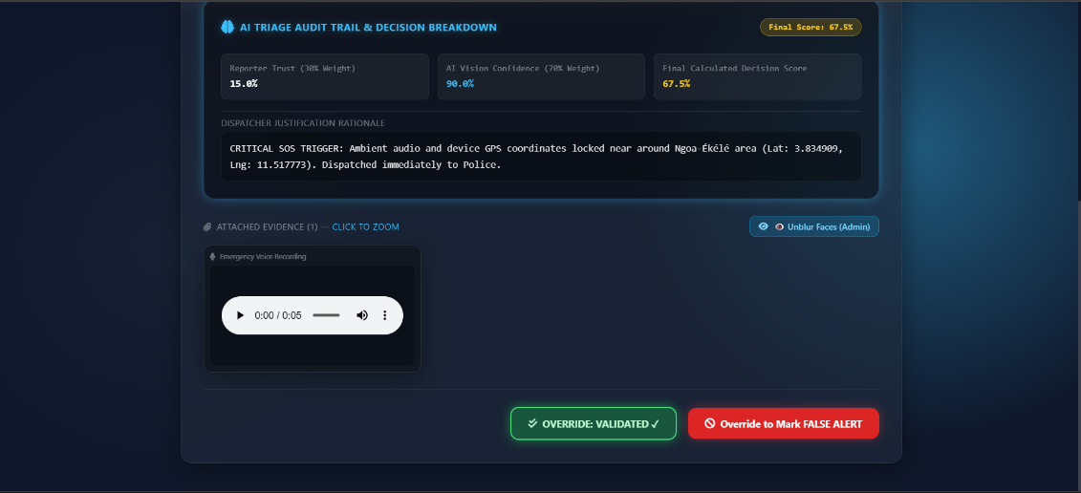
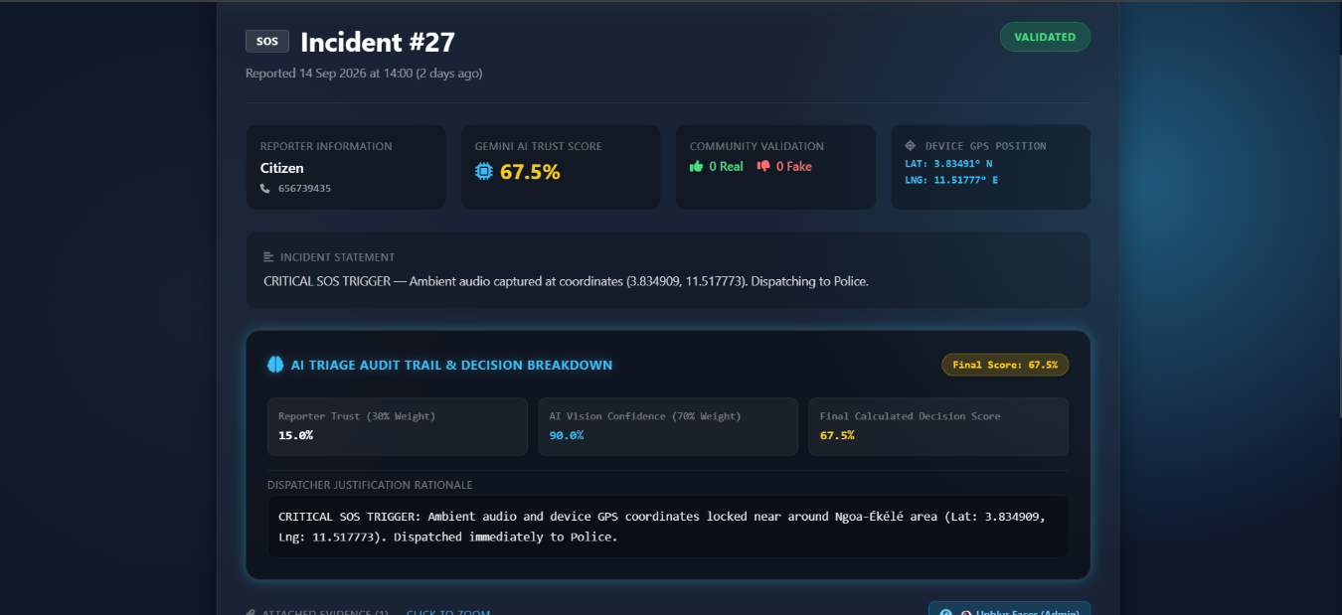
Figure 46: Reported Incident details' page part 2
Figure 47: Reported Incident details' page part 1

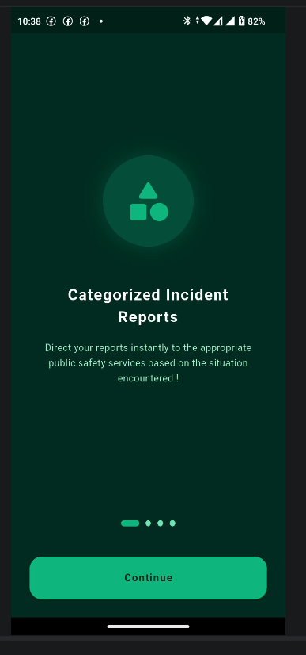
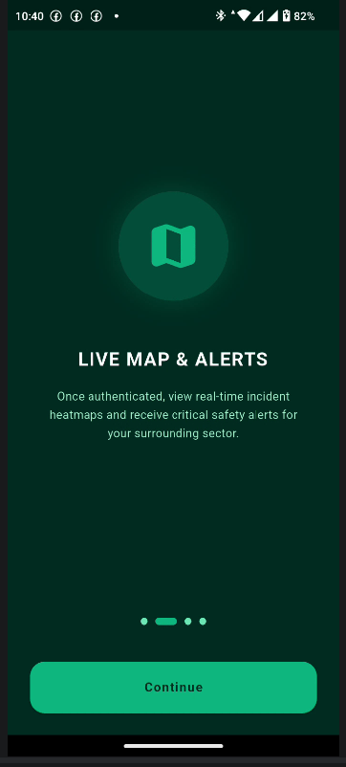
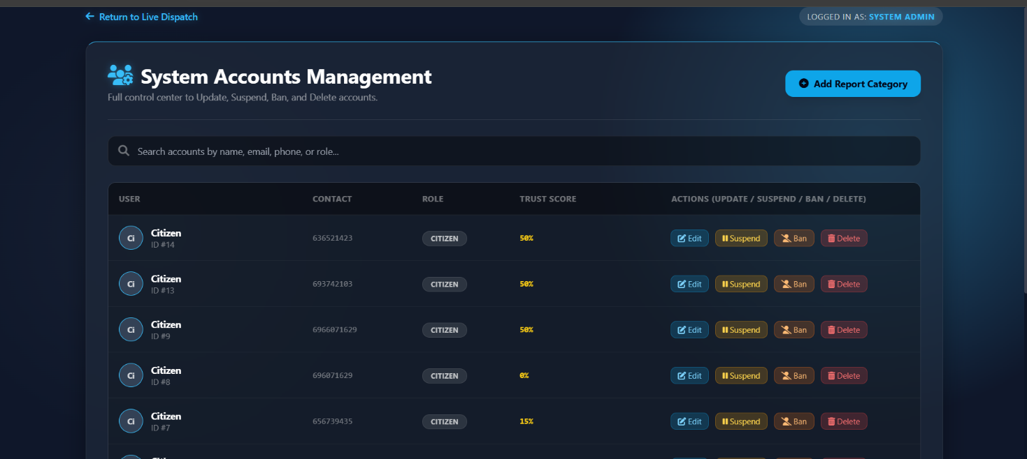
Figure 48: Accounts Management Interface
Figure 49:Mobile Landing page 1
Figure 50:Mobile Landing page 2
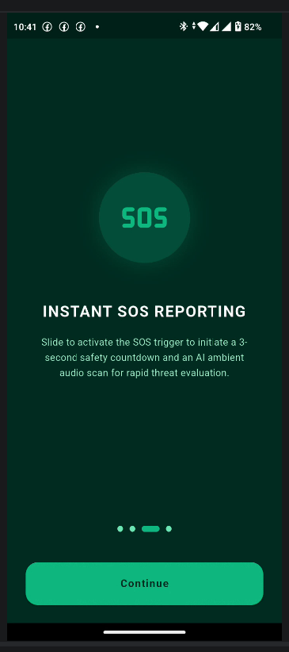
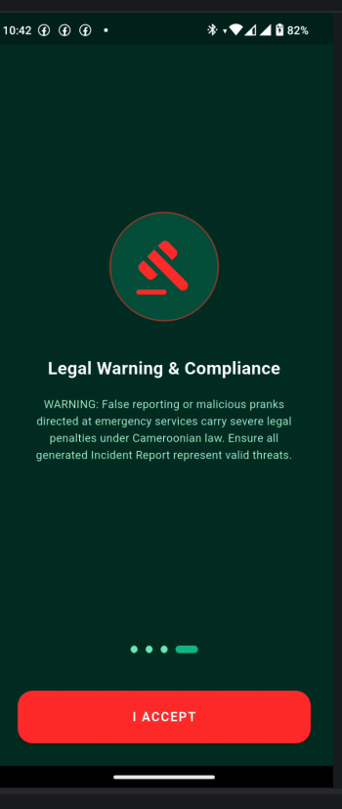
Figure 51: Mobile Landing page 4
Figure 52:Mobile Landing page 3
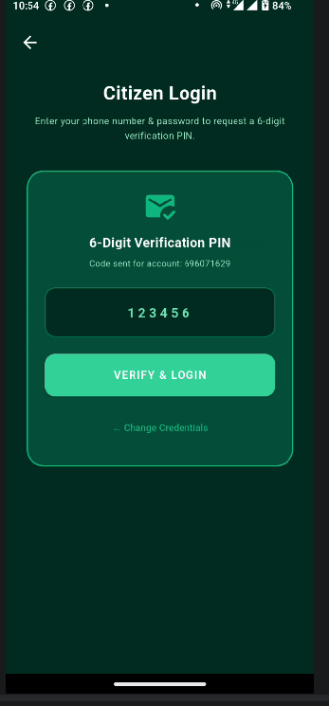
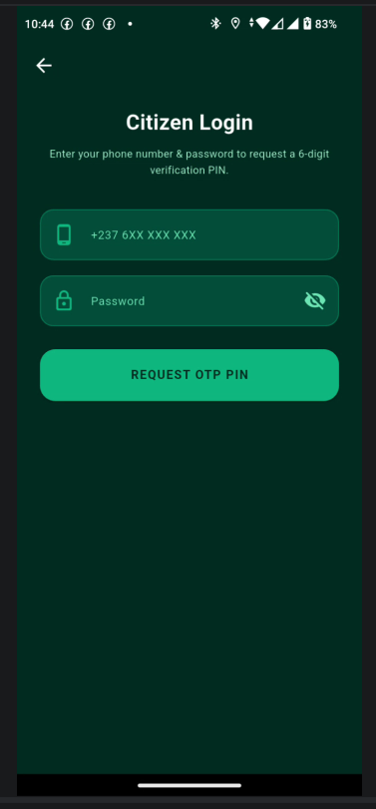
Figure 53: 6-digit Verification form
Figure 54: Mobile Login page

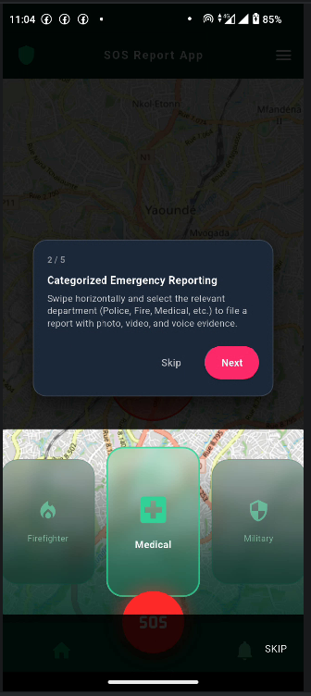
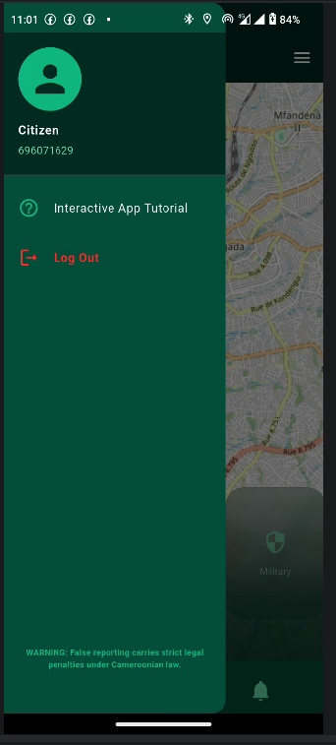
Figure 55: Drawer tool Interface
Figure 56: Standard Incident Reporting Cards
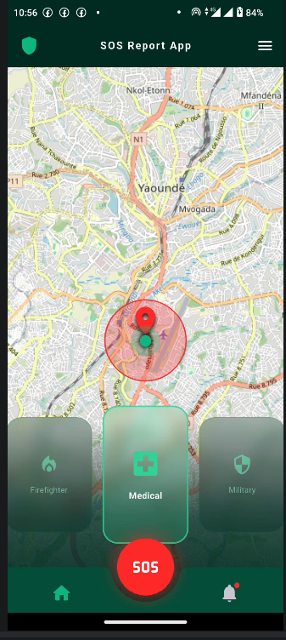
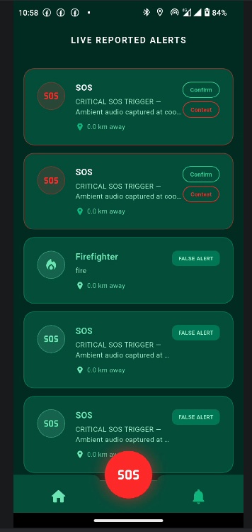
Figure 57: Mobile application Dashboard
Figure 58: Alerts Screen

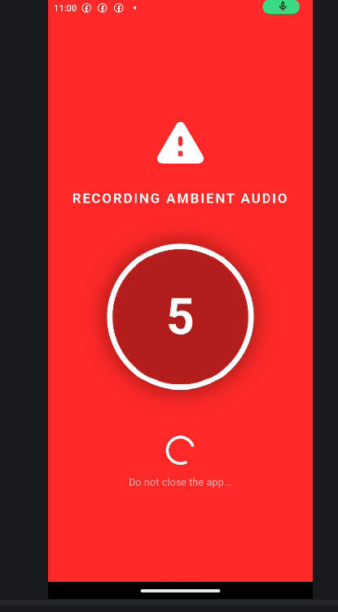
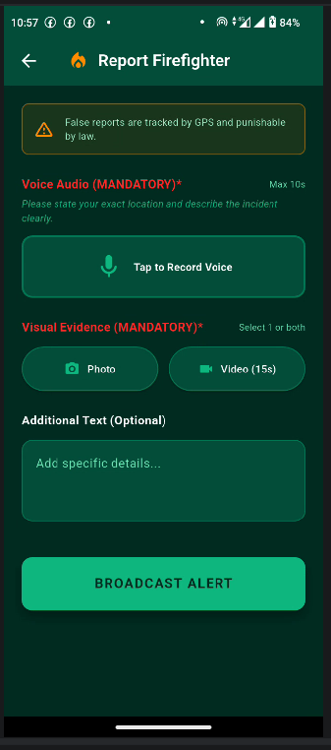
Figure 59: Standard Report Incident form
Figure 60: SOS Report triggered

CONCLUSION
Once the platform is set up, it is essential to provide a manual to assist its various users. Therefore, we have outlined the different tools required for installation and detailed the installation process to ensure the application runs smoothly. Additionally, we have explained how users can effectively navigate and utilize the platform once the environment is fully configured. This manual will serve as a comprehensive guide to maximize the user experience.

PERSPECTIVES

While the SOS Report MVP successfully achieves its primary objectives, the platform possesses significant potential for future enhancement such as:
- Instant Text First, Media Later
The exact millisecond you hit the SOS button, the app sends a tiny text message with your GPS location and device ID first, before it tries to upload photos or audio.
Even if your phone gets damaged or turned off while uploading a heavy video, the emergency services already have your exact location.
- Offline SMS Fallback Architecture
If the app notices you have no 3G or 4G data, it automatically converts your GPS coordinates and User ID into a standard text message (SMS) and sends it to a free emergency server number.
Guarantees life-saving functionality in zones with poor internet coverage
- Live Real-Time Tracking
The app continuously streams your changing GPS location to the server using WebSocket, drawing a moving line on the map.
It solves moving emergencies like a taxi kidnapping or a high-speed chase where sending a single static location isn't enough.
- Unlock other functionalities of the system
Enhancing the system by unlocking blocked functionalities and adding others such as “confirm arrival” and other system functionalities.

GENERAL CONCLUSION

Having come to the end of our project and the end of our internship at Mercy Innovative Tech, we have achieved a lot from our internship period, it was very challenging and demanding, we had to manage stress, workload, failures and successes. Our stay in Mercy Innovative Tech was very profitable; we learned how to adapt to the professional milieu, exchange with a client, learned new development skills with technologies such as Laravel and Flutter, and to work in team. For our project, we worked on the theme “CONCEPTION AND REALIZATION OF A SMART COMMUNITY PLATFORM FOR REAL-TIME INCIDENT REPORTING (SOS REPORT)”. Our greatest desire is to provide a mean, that will help emergency services to perform a more rapid intervention time for incident reported, while avoiding them from encountering situations like pranks, and hence, reassure the victims of the incidents, as well as the citizens reporting that rescues arrive. We began by identifying the current system in place for incident reporting in Cameroon, precisely in Yaounde, the project constraints and requirements in the specification book, and then we went forth to analyze our system (SOSReport) using UML-2TUP methodology. We made use of Visual Paradigm; a modelling software used to draw our various diagrams. In order to realize our project, we used Flutter framework for our front-end, Laravel rest framework for our back end and Postgres SQL for our database. We won’t end here, updates and important improvements are going to be made in the nearest future in terms of functionality, security to make it more reliable.

ANNEXES

BIBLIOGRAPHY

- Stauffer, M. (Publication date: 2019). Laravel: Up & Running: A Hands-On Guide to Alive Web Development. O’Reilly Media.
- Windmill, E. (Publication date: 2020). Flutter in Action. Manning Publications.
- Booch, G., Rumbaugh, J., and Jacobson, I. (Publication date: 2005) The Unified Modeling Language User Guide. 2nd edn. Boston: Addison-Wesley Professional.
- Roques, P. (Publication date : 2008) UML 2 par la pratique : Études de cas et exercices corrigés. 6e éd. Paris : Eyrolles.
- National Institute of Statistics of Cameroon (INS) (Publication date : 2024) Annuaire Statistique du Cameroun 2023-2024 : Chapitre Sécurité et Protection Civile. Yaoundé : Imprimerie Nationale.
- Otterwell, M. and Davis, K. (Publication date: 2021) Computer-Aided Dispatch Systems in Developing Nations: Infrastructure Constraints and Cellular Solutions. Journal of Emergency Management, 19(4), pp. 312–329.
- PubMed record PMID: 42318574; PMC ID: PMC13272510; the PMC and PubMed (Publication date: 2025/2026). “Road traffic crash mortality in Southwest Cameroon: a multicenter hospital study”. Section “Results”, paragraph 3 line 1, 4
- AllAfrica (republishing Cameroonian press) (Publication date: 20 /02/2026). “Cameroun : Incendie meurtrier à Yaoundé - Une mère et ses cinq enfants périssent à Etoa Meki”, Located in the section “Une tragédie qui interroge sur les délais d'intervention”,
- “Information technology - Object Management Group Unified Modeling Language (OMG UML), Superstructure” published by ISO as the 2012 edition standard: ISO/IEC 19505-2

WEBOGRAPHY

- https://en.wikipedia.org/wiki/Merise visited on the 2nd of August 2026 to know more about MERISE methodology and definition
- https://www.uml-diagrams.org/uml-24-diagrams.html visited on the 2nd of August 2026 to know more about UML 2.5 definition and its diagrams
- https://mi-tech.site/ visited on the 5th of August 2026 to have more information about MI-Tech ‘s team members, roles and ongoing projects
- https://www.osidimbea.cm/gouvernement/sapeurs-pompiers/ visited on the 6th of August to know how to contact the Firefighter brigade service
- https://fr.allafrica.com/stories/202602200594.html. Visited on the 1st of September 2026 to search more info about time delay of interventions by emergency services and the impact.
- https://pubmed.ncbi.nlm.nih.gov/42318574/ Visited on the 1st of September 2026 to search more info about time delay of interventions by emergency services and the impact.
- https://www.pngwing.com/en/free-png-zctof/download Visited on the 1st of September 2026 to search logo icons for technologies used
- https://aistudio.google.com/ Visited on the 5th of September 2026 to search Google AI Studio Documentation (Gemini API):
- https://postgis.net/documentation/ Visited on the 5th of September 2026 to search PostGIS Spatial Database Reference
- https://www.twilio.com/docs/sms Visited on the 5th of September 2026 to search Twilio Programmable SMS API
- https://lefisk.cm/outils/mercuriale Visited on the 15th of September 2026 to search official prices for hardware components

TABLE OF CONTENT

DEDICATION I
ACKNOWLEDGEMENTS II
SUMMARY III
LIST OF TABLES IV
LIST OF FIGURES VI
GLOSSARY IX
ABSTRACT XI
RESUME XII
GENERAL INTRODUCTION 1
PHASE ONE: INSERTION PHASE 2
INTRODUCTION 4
I. WELCOME AND INSERTION 5
II. GENERAL PRESENTATION OF THE COMPANY 6
A. History and Mission 6
B. Aims 7
C. Values 7
D. Activities 8
E. Ongoing Projects 8
F. Team 9
III. ORGANIZATION OF THE COMPANY 10
IV. GEOGRAPHICAL LOCATION 11
V. HARDWARE AND SOFTWARE RESOURCES 12
A. HARDWARE RESOURCES 12
B. SOFTWARE RESOURCES 13
VI. BRIEF PRESENTATION OF THE PROJECT THEME 14
CONCLUSION 15
PHASE TWO: TECHNICAL PHASE 16
FILE 1: THE EXISTING SYSTEM 18
INTRODUCTION 20
I. PRESENTATION OF THE PROJECT THEME 21
II. DESCRIPTION OF THE EXISTING SYSTEM 22
III. CRITICISMS OF THE EXISTING SYSTEM 24
IV. PROBLEMATIC 25
V. PROPOSED SOLUTION 26
CONCLUSION 27
FILE 2: THE SPECIFICATION BOOK 28
INTRODUCTION 30
I. CONTEXT AND JUSTIFICATION OF THE PROJECT 31
A. Context 31
B. Justification 31
II. OBJECTIVES OF THE PROJECT 32
A. General Objective 32
B. Specific Objectives 32
III. EXPRESSION OF NEEDS 33
A. Functional Needs 33
B. Non-Functional Needs 35
IV. PROJECT PLANNING 36
A. Chronogram of Activities 36
B. Gantt Project planning 37
V. ESTIMATED COST OF THE PROJECT 38
A. Software Resources 38
B. Hardware Resources 39
C. Human Resources 40
VI. PROJECT CONSTRAINTS 42
VII. DELIVERABLES 42
CONCLUSION 43
FILE 3: THE ANALYSIS PHASE 44
INTRODUCTION 46
I. METHODOLOGY 47
A. Comparative Study of UML and MERISE 47
B. Comparative Study of Unified Processes 49
II. MODELING OF THE PROPOSED SOLUTION 52
A. Use Case Diagram 52
General Use Case Diagram of SOS Report 55
Specific Use Case Diagrams 56
Textual Descriptions of Use Cases 57
B. Communication Diagram 65
Communication Diagrams for SOS Report 66
C. Sequence Diagram 68
Sequence Diagrams for SOS Report 70
D. Activity Diagram 73
Activity Diagrams for SOS Report 75
CONCLUSION 78
FILE 4: CONCEPTION PHASE 79
INTRODUCTION 81
I. CAPTURE OF TECHNICAL NEEDS 82
A. Physical Architecture 82
B. Logical Architecture 83
II. RELATED UML DIAGRAMS 84
A. Class Diagram 84
Class Diagram of SOS Report 86
B. State Machine Diagram 87
State machine diagram of SOS Report 89
C. Package Diagram 90
Package Diagram of SOS Report 92
CONCLUSION 93
FILE 5: REALIZATION PHASE 94
INTRODUCTION 96
I. RELATED UML DIAGRAMS 97
A. Deployment Diagram 97
Deployment Diagram of SOS Report 99
B. Component Diagram 100
Component Diagram of SOS Report 102
II. TECHNOLOGICAL CHOICES 103
CONCLUSION 107
FILE 6: TEST OF FUNCTIONAITIES 108
INTRODUCTION 110
I. APPLICATION FUNCTIONALITIES 111
II. TEST SHOWCASES 112
CONCLUSION 116
FILE 7: INSTALLATION GUIDE AND USER GUIDE 117
INTRODUCTION 119
I. Installation of The Application 120
II. User Guide 122
CONCLUSION 129
PERSPECTIVES 130
GENERAL CONCLUSION 131
ANNEXES XIII
BIBLIOGRAPHY XIV
WEBOGRAPHY XV
TABLE OF CONTENT XVI

